**PROJECT REPORT**

**Examining the Association Between Internet Usage and Loneliness Among Barishal University Students**

Submitted to

Md. Rashid Al Asif

Assistant Professor, Department of Computer Science & Engineering,

University of Barishal

Submitted by,

Afsan Sami

Roll: 09-003-03

Dept. of Statistics

University of Barishal

# Abstract

This study explores the association between internet usage and loneliness among students at Barishal University, aiming to shed light on the impact of digital engagement on students' social and mental well-being. Utilizing a cross-sectional design, data were collected from 393 students across various academic departments. Variables examined included demographics, internet usage patterns, and psychological factors. Statistical analyses, including correlation and regression, were conducted to assess relationships between internet habits and loneliness. Findings reveal significant associations between high internet usage for non-academic purposes, feelings of anxiety without internet access, and elevated levels of loneliness. These insights underscore the complex role of the internet as both a tool for social connection and a source of isolation. Implications for mental health support and responsible digital engagement are discussed, highlighting the need for targeted interventions to promote balanced internet use among university students.

# Table of Contents

Abstract 2

Table of Contents 3

Chapter One 6

Introduction 6

Background 6

Statement of the Problem 7

Context of the Study: Barishal University 8

Objectives of the Study 9

Impact on Academic Performance 9

Significance of the Study 10

Methodology 10

Limitations of the Study 10

Ethical Considerations 11

Chapter Two 12

Literature Review 12

Internet Usage and Loneliness: A Dual-Edged Sword 12

Impact of Internet Usage on Loneliness 12

Mediators of the Internet-Loneliness Relationship 14

Moderators of Internet Use and Loneliness 15

Impact of Internet Use on Academic Performance 16

Coping Strategies for Internet-Related Loneliness 16

Discussion and Conclusion 16

Chapter Three 17

Methodology and Data Analysis Introduction 17

Introduction 17

Selection of Project Problem 17

The Study Area and Time 17

Sampling Design and Sampling Units 17

Preparation of Questionnaire 18

Data Collection 18

Dependent Variable 18

Data Processing 19

Editing 19

Coding 19

Statistical Analysis 19

Computerization 20

Limitations of the Study 20

Analytical Framework 20

Data Analysis 21

Frequency Distribution of the Variables 22

3.2 Sex of the respondents 25

3.3 Age Distribution of the respondents 25

3.4 Residence of the respondents 26

3.6 Academic faculty of the respondents 27

3.7 Participation in Extracurricular Activities 28

3.8 Frequent Internet Use 29

29

3.9 Average daily hours spent online for non-academic purposes 29

**Figure 3.8:** Average daily hours spent online for non-academic purposes 30

3.10 Feel anxious without internet access for a few hours 30

3.11 Importance of internet connectivity for maintaining relationships with friends and family 31

3.12 Often feel lonely 31

3.13 Frequency of experiencing loneliness 32

3.14 Reason for loneliness 33

3.15 Using internet to escape loneliness 33

3.16 Experienced any mental health issues 34

3.17 Internet usage impact on sleep quality 35

3.18 Weekly meetups and chats with friends outside of class 35

Association Table of the Characteristics 36

**Demographic Characteristics** 37

**Residence and Family Income** 38

**Academic Characteristics** 38

**Internet Usage Patterns** 38

**Psychological and Social Factors** 38

**Academic Performance and Sleep Patterns** 39

**Social Engagement** 39

Simple Logistic Regression Model 40

Contingency Analysis 44

Association between Frequency of Experiencing Loneliness vs Frequent Internet Use 45

Association between Frequency of Experiencing Loneliness vs Average Daily Hours Spent Online for Non-Academic Purposes 46

Association between Frequency of Experiencing Loneliness vs Feelings of Anxiety Without Internet Access 47

Association between Frequency of Experiencing Loneliness vs Experienced any mental health issues 48

Association between Frequency of Experiencing Loneliness vs Weekly meetups and chats with friends outside of class 50

Chapter Four 52

Result Discussion and Conclusion 52

Introduction 52

Result Discussion 52

Conclusion 53

Limitations 53

Further Research Scope 53

References 54

Appendix A Supportive Materials 55

Appendix B Questionnaire 56

# Chapter One

## Introduction

### Background

The internet has become an integral component of modern life, transforming how individuals access information, conduct research, engage in commerce, and communicate globally. It has also revolutionized entertainment, education, and social interaction, offering unprecedented opportunities for learning and connection. As of 2023, an estimated 5.4 billion people—approximately 67% of the global population—are active internet users, according to the International Telecommunication Union (ITU). This figure represents a remarkable 45% growth since 2018, with 1.7 billion new users coming online in that period.

In Bangladesh, internet penetration has increased substantially over the past decade. In 2021, 39% of the population had internet access, compared to just 4.5% in 2011. This rapid growth mirrors global trends, as the internet continues to reshape various aspects of Bangladeshi society, including education, social interactions, and mental health. For university students, in particular, the internet serves as a critical tool for academic collaboration, accessing educational resources, and participating in online communities, while also being a primary medium for maintaining social relationships, engaging in entertainment, and seeking emotional support.

While the internet facilitates connections and offers numerous advantages, its increasing dominance in students’ lives has raised concerns about its impact on mental health, particularly loneliness. Loneliness, defined as a subjective feeling of social isolation despite being surrounded by others, has far-reaching consequences for psychological well-being. Research consistently links loneliness to adverse health outcomes such as depression, anxiety, sleep disturbances, and impaired academic performance.

University students are especially susceptible to loneliness due to the transitional nature of university life. Many students face the challenges of adjusting to new environments, academic pressures, and the need to form new social connections—all of which can contribute to feelings of isolation. As digital natives, these students frequently turn to the internet as a coping mechanism. However, the effects of this reliance on digital platforms for social interaction are complex and remain a subject of academic debate.

On one hand, the internet provides opportunities for maintaining relationships with distant friends and family, as well as finding new online communities. On the other hand, excessive or unbalanced use of the internet—especially passive activities such as excessive scrolling on social media—can exacerbate feelings of loneliness by displacing real-world interactions and reducing the quality of face-to-face relationships. This dual role of the internet as both a tool for connection and a potential source of isolation is at the heart of this study.

This research focuses on examining the relationship between internet usage and loneliness among students at Barishal University. By analyzing different patterns and motives for internet use, the study aims to understand how these behaviors contribute to or alleviate feelings of loneliness in this unique demographic. Given the rising internet accessibility in Bangladesh, understanding its impact on the mental health of university students is critical. This knowledge can inform the development of effective interventions that promote balanced and healthy internet use, enhancing students' overall well-being and reducing the risk of loneliness.

### Statement of the Problem

While the internet offers numerous benefits, including improved communication, access to information, and enhanced academic opportunities, it also poses significant risks to mental health, particularly in cases of excessive or problematic use. Among university students, high levels of internet use have been associated with increased feelings of loneliness, anxiety, and depression. This paradox of being digitally connected yet feeling isolated has become a critical issue, especially as students increasingly rely on digital platforms for social interaction. Moderate internet use can facilitate our lives, making tasks more manageable; however, excessive and uncontrolled internet usage can lead to negative consequences, with literature suggesting that using the internet for five hours or more per day is deemed problematic.

This study seeks to address the growing concern of internet-related loneliness among students at Barishal University. Despite the rising prevalence of internet use, little is known about its specific effects on the mental health of students in Bangladesh. Understanding the association between internet usage patterns and loneliness at Barishal University is crucial, as it will provide valuable insights into the broader implications of digital engagement on student well-being in our rapidly digitizing society.

### Context of the Study: Barishal University

Barishal University, established in 2011, is a prominent public institution in Bangladesh, serving approximately 8,000 students from diverse academic disciplines. Like many universities worldwide, Barishal University’s students are deeply integrated into the digital realm, utilizing the internet extensively for academic activities, social networking, entertainment, and various other purposes. This study examines a sample of 393 students, selected through purposive sampling, to represent a cross-section of the university’s student population.

Focusing on Barishal University offers a valuable opportunity to explore the relationship between internet use and loneliness in a non-Western context, an area that has been largely underrepresented in existing literature. While much of the research on internet use and loneliness has centered on Western populations, limited attention has been given to how these dynamics manifest in Bangladeshi or other similar cultural settings. This study addresses this research gap by investigating how Barishal University students navigate the dual role of the internet as both a tool for connection and a potential source of social isolation.

Preliminary data suggest that Barishal University students frequently engage with the internet for non-academic purposes, including social media, online gaming, and streaming entertainment, with many reporting significant levels of loneliness. Unlike their Western counterparts, who may use the internet to maintain broad social networks, Barishal University students often rely on digital platforms to stay connected with family members due to geographic, cultural, and economic constraints. This reliance on the internet for maintaining core social connections highlights the unique cultural factors that influence digital behaviors in this context.

Exploring the interplay between internet use and loneliness among Barishal University students is particularly critical given these context-specific nuances. Understanding how cultural and socio-economic factors shape students’ internet usage and its impact on their mental health is essential for designing effective interventions that address loneliness and promote well-being. This study aims to contribute valuable insights into these dynamics, offering evidence-based recommendations tailored to the needs of students within Barishal University and similar settings.

### Objectives of the Study

The primary objectives of this study are to:

* Examine the prevalence of loneliness among Barishal University students in relation to their internet usage patterns.
* Identify the main motives for internet use (e.g., academic, social media, entertainment) and how these motives correlate with feelings of loneliness.
* Investigate the mediating roles of factors such as online social support and self-esteem in the relationship between internet use and loneliness.
* Provide insights into potential interventions that can mitigate the negative effects of internet use on student mental health.

### Impact on Academic Performance

In addition to its effects on mental health, internet usage also plays a significant role in influencing students' academic performance. While the internet offers students access to vast educational resources, including e-books, academic journals, and online courses, its use for non-academic purposes—such as social media, gaming, and entertainment—can have adverse effects on academic outcomes.

Studies have shown that excessive internet use, particularly for non-academic purposes, can lead to decreased focus, poor time management, and lower academic achievement. The ease of access to entertainment and social platforms often leads to procrastination, with students spending more time online than anticipated, at the expense of their academic responsibilities. Furthermore, problematic internet use has been associated with sleep disturbances, which further negatively impacts academic performance by reducing concentration, memory retention, and overall cognitive functioning.

On the other hand, when used responsibly, the internet can significantly enhance academic performance by enabling students to access scholarly databases, collaborate with peers, and participate in online learning environments. The challenge, therefore, lies in striking a balance between academic and non-academic internet use, ensuring that students can leverage the benefits of the internet without falling into patterns of misuse that detract from their studies.

In the context of Barishal University, this study examines not only the relationship between internet usage and loneliness but also how different patterns of internet use impact students' academic performance. Understanding these dynamics is critical, as it can inform strategies to help students develop healthier internet habits that support both their academic success and mental well-being.

### Significance of the Study

This research is significant because it addresses a critical mental health issue within a population that is highly susceptible to the effects of digital engagement. By focusing on Barishal University students, the study contributes valuable context-specific knowledge that can inform targeted mental health interventions and policies at the university level. The findings will be particularly relevant for counseling services, educators, and policymakers aiming to support students in managing their digital habits and mitigating the risks associated with excessive internet use.

Moreover, the study’s results have broader implications beyond the university setting. Understanding how internet usage influences loneliness among young adults in Bangladesh can help guide national strategies aimed at promoting digital literacy, enhancing mental health support, and addressing the digital divide that continues to shape access to online resources.

### Methodology

This study employs a cross-sectional design to explore the relationship between internet usage and loneliness among Barishal University students. A total of 393 students were selected using purposive sampling from an approximate population of 8,000 students. Data were gathered using a structured questionnaire distributed in two formats: printed forms and an online Google Form. The questionnaire included items measuring demographic information, internet usage patterns, motives for internet use, and indicators of loneliness.

Statistical analyses, including correlation and regression techniques, were used to assess the association between internet usage variables and reported levels of loneliness. The study also examined potential mediators, such as online social support and self-esteem, to better understand the mechanisms underlying this relationship.

### Limitations of the Study

While this study provides valuable insights, it is not without limitations. The use of purposive sampling may limit the generalizability of the findings, as the sample may not fully represent the broader student population of Barishal University. Additionally, the cross-sectional design prevents the establishment of causal relationships between internet usage and loneliness. Future research could benefit from longitudinal studies that track changes in internet use and mental health outcomes over time.

Another limitation is the reliance on self-reported data, which may be subject to response biases such as social desirability or recall bias. Despite these limitations, the study offers a critical examination of an understudied issue in the context of Bangladeshi higher education.

### Ethical Considerations

Ethical considerations were paramount in conducting this study. Informed consent was obtained from all participants, ensuring that they were aware of the study's purpose, procedures, and their right to withdraw at any time. The confidentiality of respondents was maintained, with personal identifiers removed from the data to protect participants' privacy. The study adhered to ethical guidelines for research involving human subjects, ensuring the welfare and rights of the participants were respected throughout the research process.

# Chapter Two

## Literature Review

The increasing reliance on the internet has brought about significant changes in the social dynamics and psychological well-being of university students globally. This literature review synthesizes findings from recent studies to explore the factors contributing to the association between internet usage and loneliness among university students, with a focus on the student population at Barishal University. The review examines both the positive and negative impacts of internet use, as well as the mediators and moderators that influence this relationship.

### Internet Usage and Loneliness: A Dual-Edged Sword

Loneliness is a growing concern among university students, often described as a subjective feeling of social isolation or a lack of meaningful connection despite being surrounded by peers. The relationship between internet usage and loneliness is complex and multifaceted, with research showing both positive and negative effects depending on the context, frequency, and nature of internet use.

### Impact of Internet Usage on Loneliness

The relationship between internet usage and loneliness has been a subject of considerable research, particularly as digital platforms become central to students' social lives. While the internet can provide opportunities for social interaction and connection, it can also contribute to feelings of isolation and loneliness, especially when used excessively or in place of face-to-face communication.

#### **Positive Impacts of Internet Use**

Several studies highlight the internet’s capacity to reduce loneliness by facilitating social connectivity. Online platforms, such as social media and messaging apps, enable students to maintain communication with distant family and friends, thereby fostering a sense of social support. For instance, Valkenburg and Peter (2007) suggest that online communication, especially with known individuals, can enhance the quality of friendships and provide emotional support, thereby reducing feelings of loneliness. For students who live away from home, such as those attending Barishal University, the internet serves as a critical tool for maintaining social ties and reducing feelings of isolation.

Additionally, research by Shaw and Gant (2002) indicates that internet use can have a positive impact on psychological well-being by increasing perceived social support and decreasing loneliness. Their study found that participants who frequently used the internet for social interaction reported higher levels of connectedness and lower levels of loneliness. This finding is supported by the "social compensation hypothesis," which posits that individuals who struggle with face-to-face interactions may find solace in online communication, where social barriers are minimized (McKenna & Bargh, 2000).

#### **Negative Consequences of Excessive Internet Use**

Conversely, the internet's pervasive role in students' lives has also been linked to an increase in loneliness, particularly when used excessively or passively. The "displacement hypothesis" suggests that time spent online often displaces time that could otherwise be spent engaging in meaningful face-to-face interactions (Kraut et al., 1998). This is particularly relevant for students who may substitute real-world social experiences with digital ones, leading to shallow or superficial connections that fail to fulfill their emotional needs.

Seabrook et al. (2016) conducted a meta-analysis of studies examining the relationship between social networking site usage and loneliness, finding that while active use of social media (e.g., direct messaging) can reduce loneliness, passive use (e.g., scrolling without interaction) tends to exacerbate feelings of social isolation. The study concludes that the nature of online engagement—whether it is active or passive—plays a critical role in determining its impact on loneliness.

Furthermore, problematic internet use (PIU) has been linked to negative psychological outcomes, including loneliness, anxiety, and depression (Caplan, 2002). In particular, research on internet addiction reveals that students who use the internet excessively for escapism, entertainment, or as a coping mechanism for emotional distress are more likely to experience heightened feelings of loneliness. This pattern is evident in studies by Błachnio et al. (2016) and Tandoc et al. (2015), which found a strong correlation between social media addiction, envy, and increased loneliness among university students. The addictive nature of social media platforms and the tendency to compare oneself to others online can lead to a sense of inadequacy and isolation, contributing to increased loneliness among university students.

### Mediators of the Internet-Loneliness Relationship

Several mediating factors influence the extent to which internet usage affects loneliness. These include the quality of online social interactions, the role of online social support, and self-esteem.

#### **Online Social Support**

Online social support plays a crucial mediating role in the relationship between internet usage and loneliness. Studies suggest that individuals who actively seek social support through online platforms tend to report lower levels of loneliness, as online interactions can supplement offline social networks (Liu et al., 2022). According to a study by Zhou and Cheng (2022), online social support can buffer against the negative effects of internet use, particularly during times of social isolation, such as during the COVID-19 pandemic. However, the effectiveness of online support largely depends on the quality and depth of the relationships formed in digital spaces, which may not always equate to the support provided by offline relationships (Tian et al., 2021).

#### **Self-Esteem as a Mediator**

Self-esteem plays an important role in determining how students use the internet and how it impacts their loneliness. Low self-esteem has been associated with a greater reliance on the internet for social validation and escapism, which can, in turn, exacerbate loneliness. A study by Davis (2001) found that individuals with low self-esteem are more likely to use the internet for social compensation, seeking affirmation in online spaces to mitigate feelings of inadequacy in face-to-face interactions. This reliance on online interactions for social validation can lead to problematic internet use, where students spend excessive time online in search of affirmation, ultimately exacerbating their feelings of loneliness (Caplan, 2002).

Conversely, students with high self-esteem are more likely to engage in balanced internet use, leveraging online platforms for academic and social purposes without becoming overly dependent on them. This finding aligns with the "uses and gratifications theory," which posits that individuals use the internet to fulfill specific needs, and those with higher self-esteem tend to use it more strategically for positive outcomes (Papacharissi & Rubin, 2000).

### Moderators of Internet Use and Loneliness

In addition to mediators, several factors moderate the relationship between internet usage and loneliness, including the purpose of internet use, the intensity of usage, and individual differences such as gender.

#### **Purpose and Intensity of Internet Use**

The purpose of internet usage plays a significant role in moderating its impact on loneliness. Studies show that students who use the internet primarily for academic or informational purposes report lower levels of loneliness compared to those who use it primarily for social media or entertainment (Papacharissi & Rubin, 2000). The intensity of internet usage also matters; students who spend more time online, particularly for non-academic purposes, are more likely to experience negative psychological outcomes, including loneliness and anxiety (Caplan, 2002).

#### **Gender Differences in Internet Usage and Loneliness**

Gender has also been identified as a significant factor influencing the relationship between internet usage and loneliness. Research suggests that males and females differ in their patterns of internet use, with males more likely to engage in activities such as gaming and entertainment, while females are more inclined toward social media and communication (Li & Kirkup, 2007). These differences in internet behavior may contribute to varying levels of loneliness, with studies indicating that females who use social media excessively are more likely to experience feelings of loneliness and social comparison (Haferkamp & Krämer, 2011).

Additionally, a meta-analysis by Baloglu et al. (2018) found that females tend to report higher levels of loneliness associated with problematic internet use compared to males, potentially due to a stronger emotional investment in online relationships. This finding highlights the need for gender-specific interventions aimed at addressing the unique challenges posed by internet use among male and female students.

### Impact of Internet Use on Academic Performance

Beyond its psychological effects, internet usage also influences academic performance. While the internet provides valuable educational resources, excessive use for non-academic purposes can detract from academic achievement. A study by Junco (2012) found that students who spend more time on social media are more likely to experience declines in their academic performance due to distractions, procrastination, and reduced study time.

On the other hand, responsible use of the internet for academic purposes has been shown to enhance learning outcomes by providing access to scholarly materials, online learning platforms, and collaborative tools. Thus, the key to maximizing the benefits of internet use while minimizing its risks lies in promoting digital literacy and helping students strike a balance between academic and non-academic activities.

### Coping Strategies for Internet-Related Loneliness

Despite the potential negative effects of excessive internet use, students employ various coping mechanisms to mitigate feelings of loneliness. Rahman and Ali (2018) found that students often seek social support from peers and family members, engage in extracurricular activities, and utilize university counseling services to cope with the psychological stress associated with internet usage. These strategies are crucial for maintaining mental well-being and academic engagement, particularly for students who experience loneliness as a result of their internet habits.

### Discussion and Conclusion

This literature review synthesizes findings from various studies to provide a comprehensive understanding of the factors contributing to internet-related loneliness among university students, particularly those at Barishal University. The reviewed literature highlights the dual role of the internet in both alleviating and exacerbating loneliness, depending on how it is used. Mediating factors such as online social support and self-esteem, as well as moderating factors such as the purpose and intensity of internet usage, play a significant role in shaping the relationship between internet use and loneliness.

The literature also underscores the importance of promoting balanced internet usage and providing students with the necessary support systems to manage their online activities effectively. By understanding the complex dynamics of internet usage and loneliness, stakeholders at Barishal University can develop targeted interventions that promote healthy digital habits and support student well-being.

# Chapter Three

Methodology and Data Analysis Introduction

Introduction  
A sound methodology is essential for ensuring the reliability, validity, and overall credibility of research findings. This chapter delineates the systematic procedures employed in investigating the relationship between internet usage and loneliness among students at Barishal University. Key sections of this chapter include the study area, sampling methods, data collection procedures, data processing protocols, and the statistical techniques employed to meet the research objectives.

Selection of Project Problem  
Following our syllabus of the 2022-23 session, we were instructed to carry out a project at the beginning of the final year of our B.Sc in Statistics. For this purpose, we were divided into research groups, each with a respective supervisor. After meeting with my esteemed supervisor, we discussed various current topics that significantly affect students. I developed a strong interest in researching the “Association between Internet Usage and Loneliness among Barishal University Students” – a study focused on understanding how online activities influence students' mental well-being.

The Study Area and Time  
The research was conducted among students at the University of Barishal, encompassing both on-campus residents and off-campus students to ensure a diverse and representative sample. Data collection took place between June and September 2024, allowing ample time for comprehensive data gathering and preliminary analysis. To capture the varied impacts across the student body, participants were selected from twenty-five departments across six different faculties.

### Sampling Design and Sampling Units

In any research, an effective sampling strategy is crucial to obtaining representative data. Due to time and resource constraints, this study employed **purposive sampling** to select a subset of students who accurately represent the university's population. According to the 2024 Barishal University records, there are approximately 8,000 students across various faculties. Using Slovin’s Formula to calculate an appropriate sample size with a 5% margin of error, the following equation was applied:

$$n=\frac{N}{\left(1+{Ne}^{2}\right)}=\frac{8000}{\left(1+\left(8000⋅(0.05)^{2}\right)\right)}≈393$$

Where

N = Population size = 8000

n = Required sample size.

e = Acceptable margin of error = 0.05

### Preparation of Questionnaire

As per my study objectives, I developed a structured questionnaire under the kind supervision of my honorable supervisor. I aimed to make the questionnaire as simple and easy to understand as possible, ensuring that students could respond without any difficulty. I was also careful to avoid asking overly sensitive questions.

After meeting all the necessary criteria and receiving my supervisor’s approval, I began collecting data from the students. I selected two types of questions for my questionnaire:

1. Objective type questions
2. Short type questions

Throughout the process, I made every effort to avoid complex, ambiguous, or confusing questions, using simple language to ensure clarity for all respondents.

### Data Collection

The primary data collection for this study was conducted using both **online and offline methods** to reach a diverse set of respondents. An online survey was distributed through Google Forms, shared via platforms such as Facebook, WhatsApp, and university email lists. In addition, printed questionnaires were distributed on campus to capture responses from students who may not have access to online surveys or prefer face-to-face interaction. This mixed-methods approach ensured comprehensive data coverage and minimized non-response bias.

### Dependent Variable

The dependent variable in this study is Often feel lonely. To evaluate this, several independent variables such as internet usage frequency, average daily hours spent online for non-academic purposes, impact of internet usage on sleep quality or academic performance, anxiety or distress without internet access and whether internet is used to escape loneliness have been used. These independent variables are examined to understand their potential influence on how often students at Barishal University feel lonely.

### Data Processing

Data processing is the most important factor for carrying out research and writing a report. This process consists of three key components: editing, coding, and statistical analysis. All processing activities were carried out on a personal computer, with statistical analysis executed using R-studio and SPSS software.

### Editing

Once data collection was complete, the dataset underwent rigorous editing to eliminate errors and inconsistencies. Non-sampling errors, such as incomplete or irrelevant responses, were identified and addressed. This stage ensured that the dataset was clean, reliable, and ready for subsequent analysis.

### Coding

The collected data was then coded in preparation for analysis. Each question and response option was assigned a numerical code, facilitating statistical analysis within software applications. The coding was carefully planned to maintain clarity and consistency, ensuring that the data could be analyzed accurately without introducing bias.

### Statistical Analysis

Statistical analysis was performed using **SPSS (version 26.0)**, a widely recognized tool for social science research. The analysis aimed to identify relationships between internet usage patterns and levels of loneliness. Several statistical techniques were applied:

* **Descriptive Statistics**: Used to summarize basic information about the sample, such as age distribution, frequency of internet usage, and reported loneliness levels.
* **Correlation Analysis**: Employed to assess the strength and direction of relationships between independent variables (e.g., internet use patterns) and the dependent variable (loneliness).
* **Regression Analysis**: Used to predict levels of loneliness based on key predictors, such as time spent on social media and the purpose of internet use.

The results of these analyses will be presented in subsequent chapters, using tables and graphs to clearly illustrate findings.

### Computerization

The data processing and analysis were conducted entirely on a personal computer. **SPSS (version 26.0)** was the primary software for statistical analysis, with **Microsoft Excel (version 2019)** used for data tabulation and visualization. **Microsoft Word (version 2019)** was used for composing and formatting the research report.

### Limitations of the Study

While this study provides valuable insights into the association between internet use and loneliness among Barishal University students, several limitations must be acknowledged:

1. **Sampling Constraints**: Due to time and resource limitations, a purposive sampling technique was used, which may limit the generalizability of the findings.
2. **Self-reported Data**: The study relies on self-reported measures, which may be influenced by social desirability bias or inaccurate recollections.
3. **Cross-sectional Design**: The study’s cross-sectional nature restricts causal inference, as it captures data at a single point in time rather than over a longitudinal period.

Analytical Framework  
In this study, the analytical framework was developed to evaluate the relationship between internet usage and feelings of loneliness among Barishal University students. Several independent variables related to internet usage were considered to understand their effect on loneliness.

i. **Response Variable**: Loneliness (measured by the frequency of feeling lonely).  
ii. **Explanatory Variables**: Internet usage patterns (frequency, purpose), online social support, and anxiety related to internet use.

The following analytical framework was used to guide the study:

* **Internet Usage Patterns** ⟶ **Loneliness Levels**
* **Online Social Support** ⟶ **Mitigation of Loneliness**
* **Internet Anxiety** ⟶ **Potential Increase in Loneliness**

This framework captures the interaction between how students use the internet and how it influences their emotional well-being, particularly their experiences of loneliness.

### Data Analysis

The data analysis in this study involved three main components: the frequency distribution of demographic and internet usage variables, the assessment of loneliness indicators, and a logistic regression model to identify key predictors of loneliness among students. First, the frequency distribution of variables provided a comprehensive overview of the sample, showing the majority of students were 22 years or older, predominantly male, and from science-related faculties. Most students reported consistent internet access and high levels of daily internet usage, particularly for non-academic purposes, reflecting strong digital connectivity among the student population.

Next, the frequency distribution of loneliness indicators revealed that a significant proportion of students experienced feelings of loneliness. Many students reported factors such as "Distance from Home" and "Introversion" as primary contributors to their feelings of isolation. Additionally, the analysis highlighted that internet use, while essential for social connection, often correlated with disrupted sleep patterns, potentially exacerbating feelings of loneliness and impacting students' well-being.

Finally, the logistic regression model identified age, internet usage frequency, academic year, and family income as significant predictors of loneliness. Older students and those in higher academic years reported higher instances of loneliness, possibly due to academic pressures and reduced face-to-face interaction. Students from lower-income backgrounds and those who reported frequent internet usage were also at an increased risk of loneliness. The model showed that students in their first year of study were less likely to experience loneliness compared to those in higher years, suggesting that social connections may diminish as students progress through their university journey.

Although factors such as family size and housing arrangements were not significant predictors, the analysis emphasized the multifaceted impact of internet usage and social connection factors on student loneliness, underscoring the need for targeted interventions to enhance students' social well-being.

### Frequency Distribution of the Variables

*Table 3.1: Characteristics of the Study*

| **Characteristic** | **N = 393***1* |
| --- | --- |
| **Frequency of experiencing loneliness** |  |
| Never | 31 (7.89) |
| Rarely | 105 (26.72) |
| Sometimes | 195 (49.62) |
| Often | 49 (12.47) |
| Always | 13 (3.31) |
| **Sex** |  |
| Male | 221 (56.23) |
| Female | 172 (43.77) |
| **Age** |  |
| age under 22 | 127 (32.32) |
| greater than or equal to 22 | 266 (67.68) |
| **Residence** |  |
| Hall | 179 (45.55) |
| Mess | 180 (45.80) |
| With family | 34 (8.65) |
| **Monthly family income** |  |
| Less than BDT 18,000 per month | 147 (37.40) |
| BDT 18,000 to BDT 45,000 per month | 196 (49.87) |
| BDT 45,000 to BDT 135,000 per month | 44 (11.20) |
| More than BDT 135,000 per month | 6 (1.53) |
| **Academic faculty** |  |
| Science and Engineering | 214 (54.45) |
| Non-Science and Engineering | 179 (45.55) |
| **Current academic status** |  |
| Undergraduate | 348 (88.55) |
| Graduated | 45 (11.45) |
| **Participation in extracurricular activities** | 233 (59.29) |
| **Internet connection availability** | 383 (97.46) |
| **Frequent internet use** | 349 (88.80) |
| **Average daily hours spent online for non-academic purposes** |  |
| Less than 2 hours | 36 (9.16) |
| 2-4 hours | 149 (37.91) |
| 4-6 hours | 130 (33.08) |
| Above 6 hours | 78 (19.85) |
| **Online part-time job** | 34 (8.65) |
| **Feel anxious without internet access for a few hours** |  |
| Never | 53 (13.49) |
| Sometimes | 280 (71.25) |
| Always | 60 (15.27) |
| **Importance of internet connectivity for maintaining relationships with friends and family** |  |
| Very importan | 131 (33.33) |
| Importan | 176 (44.78) |
| Slightly importan | 77 (19.59) |
| Not importan | 9 (2.29) |
| **Often feel lonely** | 240 (61.07) |
| **Reason for your loneliness** |  |
| Introvert | 63 (16.03) |
| Few friends | 40 (10.18) |
| Family problem | 45 (11.45) |
| Personal Relationships | 30 (7.63) |
| Distance from Home | 124 (31.55) |
| Others | 91 (23.16) |
| **Using internet to escape loneliness** |  |
| Yes | 232 (59.03) |
| No | 74 (18.83) |
| Rarely | 87 (22.14) |
| **Experienced any mental health issues** | 118 (30.03) |
| **Internet usage affecting academic performance** |  |
| Yes | 252 (64.12) |
| No | 71 (18.07) |
| Not sure | 70 (17.81) |
| **Internet usage impact on sleep quality** |  |
| Significantly | 129 (32.82) |
| Moderately | 118 (30.03) |
| Slightly | 91 (23.16) |
| Not at all | 55 (13.99) |
| **Hours slept per day** |  |
| Less than 4 hours | 10 (2.54) |
| 4-6 hours | 121 (30.79) |
| 6-8 hours | 219 (55.73) |
| More than 8 hours | 43 (10.94) |
| **Weekly meetups and chats with friends outside of class** |  |
| Never | 37 (9.41) |
| Once | 70 (17.81) |
| 2-3 times | 150 (38.17) |
| 4-5 times | 64 (16.28) |
| More than 5 times | 72 (18.32) |
| *1*n (%) | |

The study sample comprises 393 students, providing comprehensive insights into their experiences with loneliness, demographic characteristics, internet usage habits, and social engagement. **Frequency of experiencing loneliness** reveals varied experiences within the group: nearly half of the students (49.62%) report feeling lonely "sometimes," 12.47% report loneliness "often," and 3.31% feel lonely "always." In contrast, 7.89% of students indicate they "never" feel lonely, while 26.72% experience loneliness only "rarely." These data suggest that while loneliness is common, the intensity of this experience varies significantly among the students. **Demographic analysis** shows a fairly balanced gender distribution, with 56.23% male and 43.77% female students. A majority (67.68%) of the sample is aged 22 years or older, indicating a predominantly older student cohort. In terms of **living arrangements**, students are almost evenly split, with 45.55% residing in university halls and 45.80% in rented accommodations (or “mess” arrangements), while a smaller group (8.65%) lives with family. Economic data suggest that most students come from lower-income backgrounds, with 37.40% reporting family incomes below BDT 18,000 per month and 49.87% reporting incomes between BDT 18,000 and BDT 45,000. Only 1.53% of students come from families earning more than BDT 135,000 monthly. Academically, undergraduates make up the majority of the sample (88.55%), with a large portion enrolled in science and engineering programs (54.45%). **Extracurricular participation** is relatively high, with 59.29% of students engaged in activities beyond academics, suggesting a moderate level of involvement in non-academic pursuits. **Internet connectivity** is nearly universal, with 97.46% reporting access to the internet and 88.80% indicating frequent use. When it comes to non-academic engagement, the majority (57.76%) report spending between 2 and 6 hours online daily, underscoring substantial digital engagement beyond their studies. Despite the advantages of internet access, **digital connectivity** also appears to generate occasional stress for some students. Specifically, 15.27% of the sample consistently feel anxious without internet access, while 71.25% report occasional anxiety in its absence. Furthermore, internet connectivity is deemed essential for social interactions, with 78.11% rating it as "important" or "very important" for maintaining relationships with friends and family. **The reasons for loneliness** among the students are diverse: 31.55% attribute loneliness to being away from home, while 16.03% link it to introversion. In response to loneliness, 59.03% of students use the internet as a coping mechanism, indicating a reliance on digital interactions for emotional support. **Mental health concerns** are prominent, with 30.03% of students reporting mental health issues. Additionally, 64.12% of the sample believes that internet use impacts their academic performance, suggesting that online engagement may compete with academic obligations. **Sleep quality** is also affected by internet use, with 32.82% of students reporting significant impacts on sleep. Most students (55.73%) sleep between 6 and 8 hours per night, though a smaller segment (2.54%) reports fewer than 4 hours of sleep, highlighting a minority who experience restricted rest. Regarding **social engagement outside of class**, 38.17% of students meet friends 2-3 times per week, and 18.32% meet more than five times per week, underscoring varied levels of in-person social activity among the group.

### 3.2 Sex of the respondents

The table 3.2 shows the percentage and frequency distribution of respondents according to their sex

**Table 3:2:** Sex

|  |  |  |  |  |  |  |  |
| --- | --- | --- | --- | --- | --- | --- | --- |
| **Sex of the students** | |  |  |  |  |  | **N=393** |
|  | |  |  | Frequency |  |  | Percent |
|  | Male |  |  | 221 |  |  | 56.2 |
| Female |  |  | 172 |  |  | 43.8 |
| Total |  |  | 393 |  |  | 100.0 |

The table shows that 43.8% respondents are female and 56.2% are male.

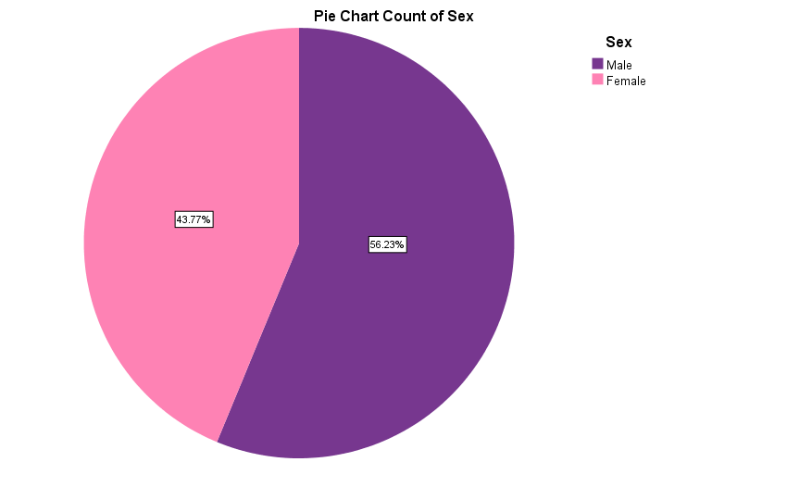

**Figure 3.1:** Pie chart of the respondents by sex

### 3.3 Age Distribution of the respondents

**Table 3.3:** Age

|  |  |  |  |  |  |
| --- | --- | --- | --- | --- | --- |
| **Age** | |  |  |  | **N=393** |
|  | |  | Frequency |  | Percent |
|  | Less than 22 years |  | 127 |  | 32.3 |
| Greater than or equal to 22 years |  | 266 |  | 67.7 |
| Total |  | 393 |  | 100.0 |

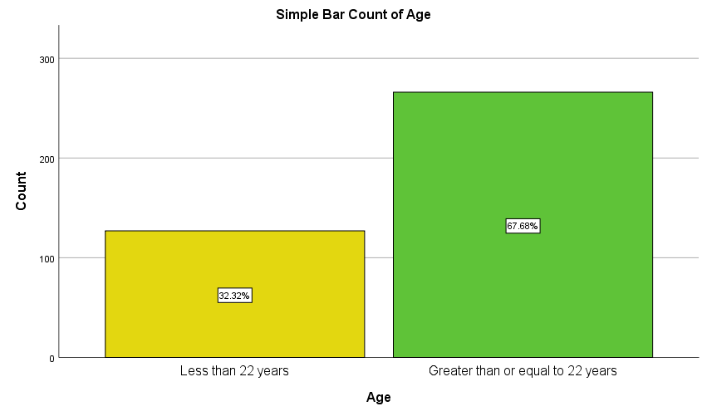

**Figure 3.2:** Percentage distribution of age in interval of the respondents

### 3.4 Residence of the respondents

**Table 3.4:** Residence

|  |  |  |  |  |  |
| --- | --- | --- | --- | --- | --- |
| **Residence** | |  |  |  | **N=393** |
|  | |  | Frequency |  | Percent |
|  | Hall |  | 179 |  | 45.5 |
| Mess |  | 180 |  | 45.8 |
| With family |  | 34 |  | 8.7 |
| Total |  | 393 |  | 100.0 |

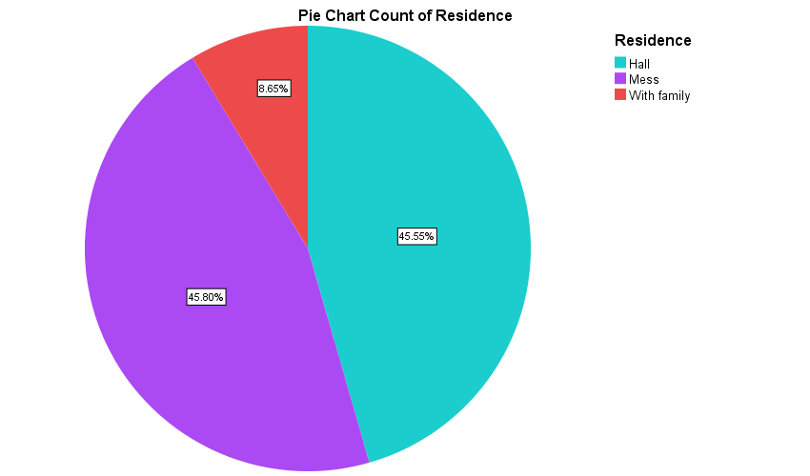

**Figure 3.3:** Pie chart of the respondents by residence

**3.5 Monthly family income of the respondents**

Table 3.5: Monthly family income

|  |  |  |  |  |  |
| --- | --- | --- | --- | --- | --- |
| **Monthly family income** | |  |  |  | **N=393** |
|  | |  | Frequency |  | Percent |
|  | Less than BDT 18,000 per month |  | 147 |  | 37.4 |
| BDT 18,000 to BDT 45,000 per month |  | 196 |  | 49.9 |
| BDT 45,000 to BDT 135,000 per month |  | 44 |  | 11.2 |
| More than BDT 135,000 per month |  | 6 |  | 1.5 |
| Total |  | 393 |  | 100.0 |

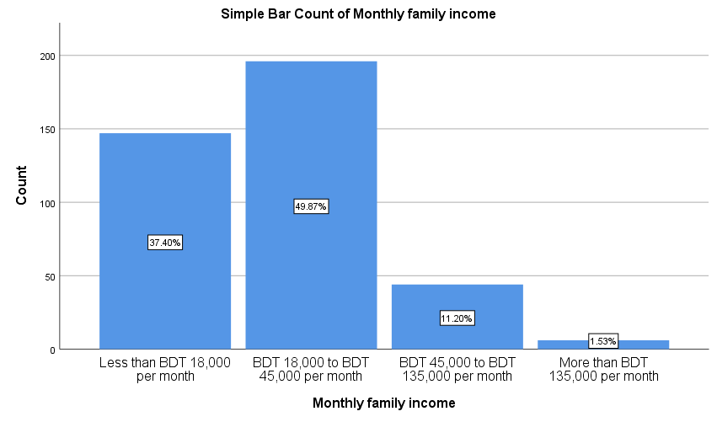

**Figure 3.4:** Monthly family income

### 3.6 Academic faculty of the respondents

**Table 3.6:** Academic faculty

|  |  |  |  |  |  |
| --- | --- | --- | --- | --- | --- |
| **Academic faculty** | |  |  |  | **N=393** |
|  | |  | Frequency |  | Percent |
|  | Science and Engineering |  | 214 |  | 54.5 |
| Non-Science and Engineering |  | 179 |  | 45.5 |
| Total |  | 393 |  | 100.0 |

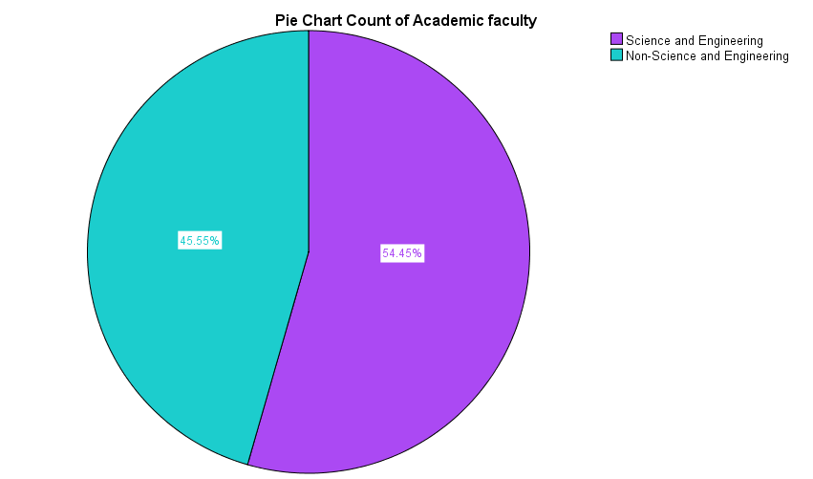

**Figure 3.5:** Academic faculty

### 3.7 Participation in Extracurricular Activities

**Table 3.7:** Participation in extracurricular activities

|  |  |  |  |  |  |  |
| --- | --- | --- | --- | --- | --- | --- |
| **Extracurricular activities** | |  |  |  |  | **N=393** |
|  | |  |  | Frequency |  | Percent |
|  | Yes |  |  | 233 |  | 59.3 |
| No |  |  | 160 |  | 40.7 |
| Total |  |  | 393 |  | 100.0 |

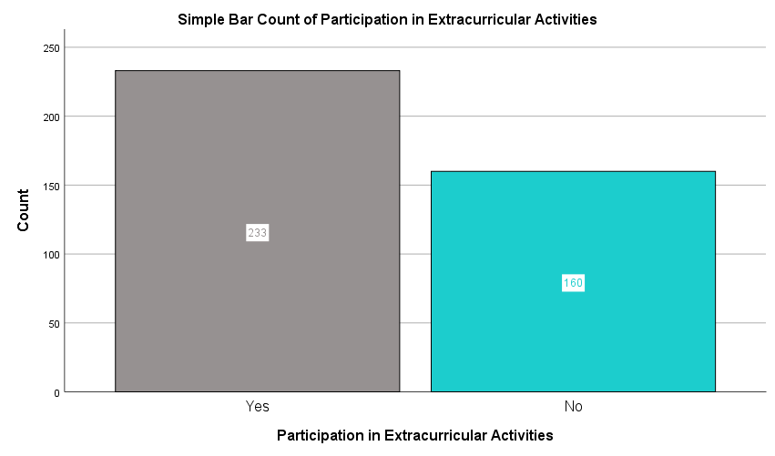**Figure 3.6:** Participation in extracurricular activities

### 3.8 Frequent Internet Use

**Table 3.8:** Frequent Internet Use

|  |  |  |  |  |  |  |  |
| --- | --- | --- | --- | --- | --- | --- | --- |
| **Frequent Internet Use** | |  |  |  |  |  | **N=393** |
|  | |  |  |  | Frequency |  | Percent |
|  | Yes |  |  |  | 349 |  | 88.8 |
| No |  |  |  | 44 |  | 11.2 |
| Total |  |  |  | 393 |  | 100.0 |

### 

**Figure 3.7:** Frequent Internet Use

### 

### 3.9 Average daily hours spent online for non-academic purposes

**Table 3.9:** Average daily hours spent online for non-academic purposes

|  |  |  |  |  |  |  |  |  |
| --- | --- | --- | --- | --- | --- | --- | --- | --- |
| **Average daily hours spent online for non-academic purposes** | |  |  |  |  |  |  | **N=393** |
|  | |  |  |  |  | Frequency |  | Percent |
|  | Less than 2 hours |  |  |  |  | 36 |  | 9.2 |
| 2-4 hours |  |  |  |  | 149 |  | 37.9 |
| 4-6 hours |  |  |  |  | 130 |  | 33.1 |
| Above 6 hours |  |  |  |  | 78 |  | 19.8 |
| Total |  |  |  |  | 393 |  | 100.0 |

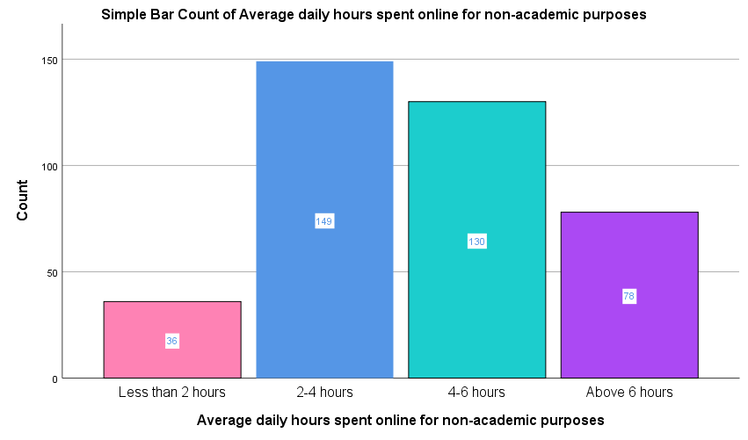

**Figure 3.8:** Average daily hours spent online for non-academic purposes

### 3.10 Feel anxious without internet access for a few hours

**Table 3.10:** Feel anxious without internet access for a few hours

|  |  |  |  |  |  |
| --- | --- | --- | --- | --- | --- |
| **Feel anxious without internet access for a few hours** | |  |  |  | **N=393** |
|  | |  | Frequency |  | Percent |
|  | Never |  | 53 |  | 13.5 |
| Sometimes |  | 280 |  | 71.2 |
| Always |  | 60 |  | 15.3 |
| Total |  | 393 |  | 100.0 |

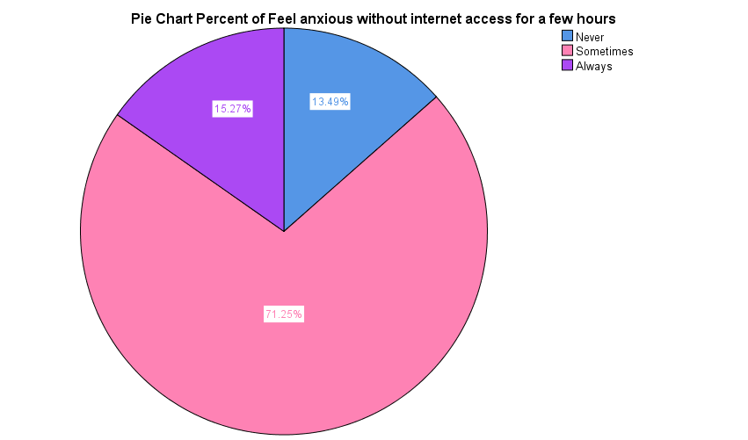

**Figure 3.9:** Feel anxious without internet access for a few hours

### 3.11 Importance of internet connectivity for maintaining relationships with friends and family

**Table 3.11:** Importance of internet connectivity for maintaining relationships with friends and family

|  |  |  |  |  |  |  |  |
| --- | --- | --- | --- | --- | --- | --- | --- |
| **Importance of internet connectivity for maintaining relationships with friends and family** | |  |  |  |  |  | **N=393** |
|  | |  |  | Frequency |  |  | Percent |
|  | Very important |  |  | 131 |  |  | 33.3 |
| Important |  |  | 176 |  |  | 44.8 |
| Slightly important |  |  | 77 |  |  | 19.6 |
| Not important |  |  | 9 |  |  | 2.3 |
| Total |  |  | 393 |  |  | 100.0 |

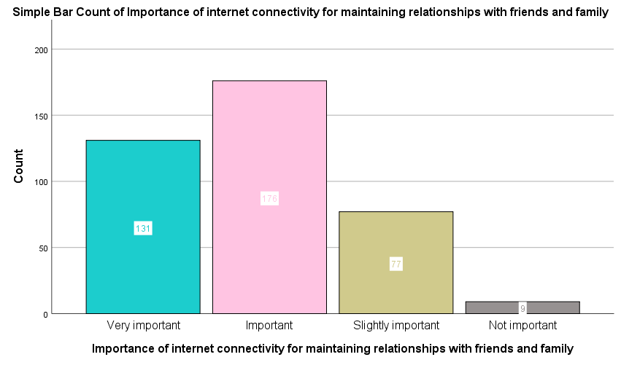

**Figure 3.10:** Importance of internet connectivity for maintaining relationships with friends and family

### 3.12 Often feel lonely

**Table 3.12:** Often feel lonely

|  |  |  |  |  |  |
| --- | --- | --- | --- | --- | --- |
| **Often feel lonely** | |  |  |  | **N=393** |
|  | |  | Frequency |  | Percent |
|  | Yes |  | 240 |  | 61.1 |
| No |  | 153 |  | 38.9 |
| Total |  | 393 |  | 100.0 |

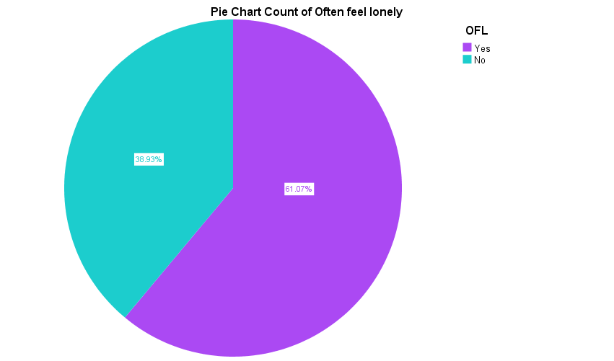

**Figure 3.11:** Often feel lonely

### 3.13 Frequency of experiencing loneliness

**Table 3.13:** Frequency of experiencing loneliness

|  |  |  |  |  |  |
| --- | --- | --- | --- | --- | --- |
| **Frequency of experiencing loneliness** | |  |  |  | **N=393** |
|  | |  | Frequency |  | Percent |
|  | Never |  | 31 |  | 7.9 |
| Rarely |  | 105 |  | 26.7 |
| Sometimes |  | 195 |  | 49.6 |
| Often |  | 49 |  | 12.5 |
| Always |  | 13 |  | 3.3 |
| Total |  | 393 |  | 100.0 |

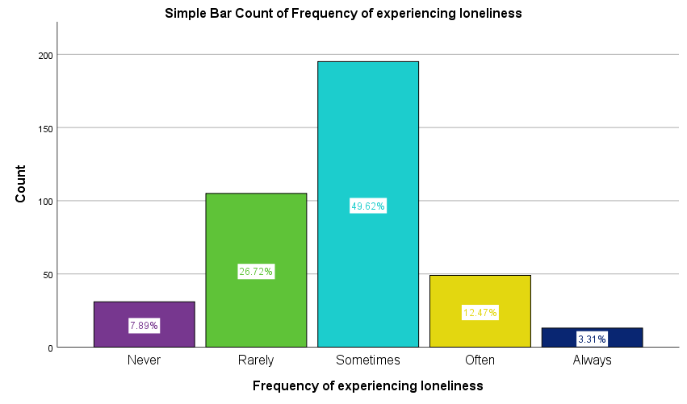

**Figure 3.12:** Frequency of experiencing loneliness

### 3.14 Reason for loneliness

**Table 3.14:** Frequency of experiencing loneliness

|  |  |  |  |  |  |
| --- | --- | --- | --- | --- | --- |
| **Reason for loneliness** | |  |  |  | **N=393** |
|  | |  | Frequency |  | Percent |
|  | Introvert |  | 63 |  | 16.0 |
| Few friends |  | 40 |  | 10.2 |
| Family problem |  | 45 |  | 11.5 |
| Personal Relationships |  | 30 |  | 7.6 |
| Distance from Home |  | 124 |  | 31.6 |
| Others |  | 91 |  | 23.2 |
| Total |  | 393 |  | 100.0 |

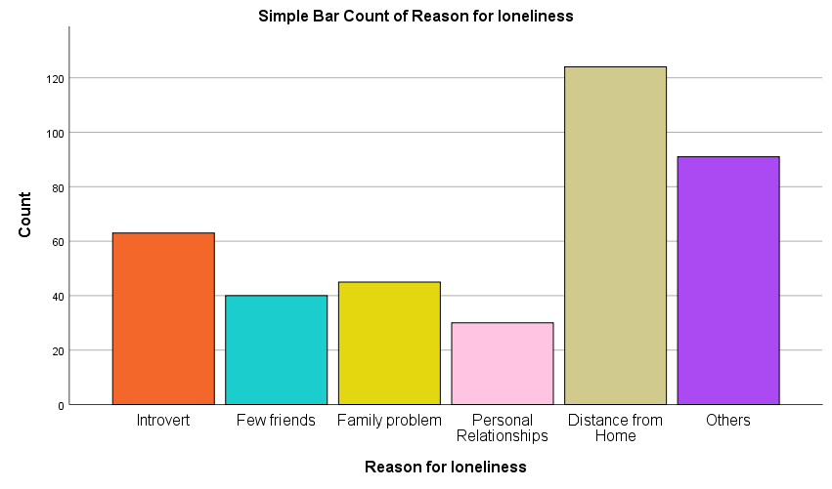

**Figure 3.13:** Reason for loneliness

### 3.15 Using internet to escape loneliness

**Table 3.15:** Using internet to escape loneliness

|  |  |  |  |  |  |
| --- | --- | --- | --- | --- | --- |
| **Using internet to escape loneliness** | |  |  |  | **N=393** |
|  | |  | Frequency |  | Percent |
|  | Yes |  | 232 |  | 59.0 |
| No |  | 74 |  | 18.8 |
| Rarely |  | 87 |  | 22.1 |
| Total |  | 393 |  | 100.0 |

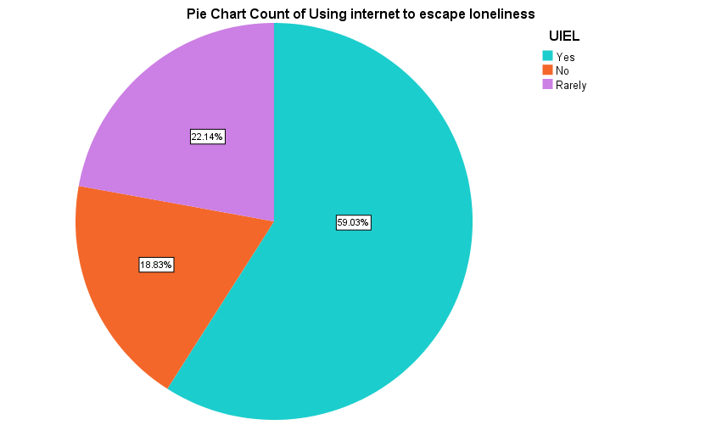

**Figure 3.14:** Using internet to escape loneliness

### 3.16 Experienced any mental health issues

**Table 3.16:** Experienced any mental health issues

|  |  |  |  |  |
| --- | --- | --- | --- | --- |
| **Experienced any mental health issues** | |  |  | **N=393** |
|  | |  | Frequency | Percent |
|  | Yes |  | 118 | 30.0 |
| No |  | 275 | 70.0 |
| Total |  | 393 | 100.0 |

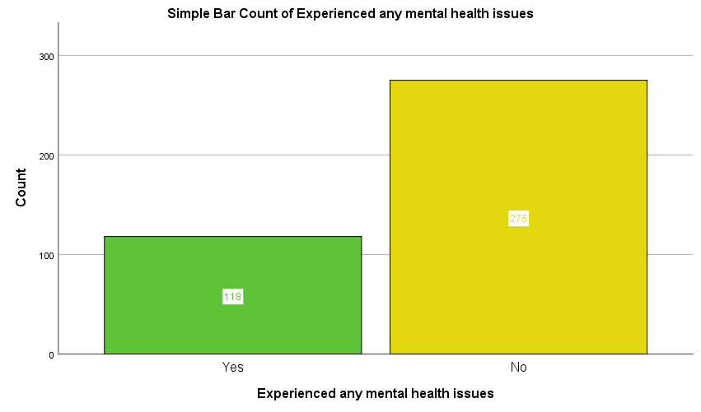

**Figure 3.15:** Experienced any mental health issues

### 3.17 Internet usage impact on sleep quality

**Table 3.17:** Internet usage impact on sleep quality

|  |  |  |  |  |
| --- | --- | --- | --- | --- |
| **Internet usage impact on sleep quality** | |  |  | **N=393** |
|  | |  | Frequency | Percent |
|  | Significantly |  | 129 | 32.8 |
| Moderately |  | 118 | 30.0 |
| Slightly |  | 91 | 23.2 |
| Not at all |  | 55 | 14.0 |
| Total |  | 393 | 100.0 |

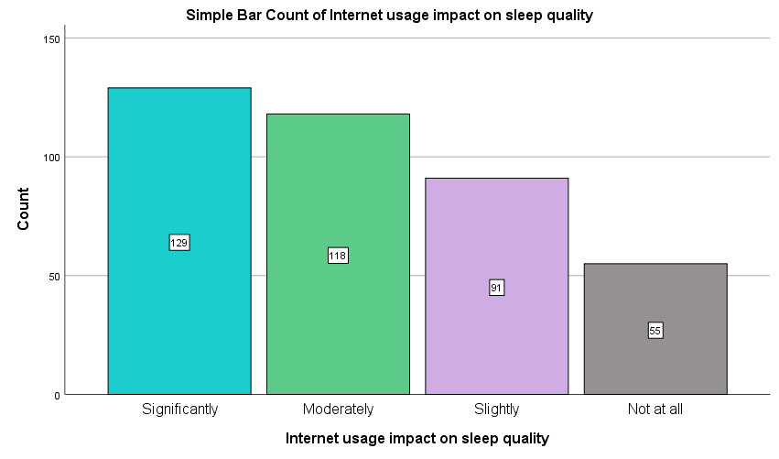

**Figure 3.16:** Internet usage impact on sleep quality

### 3.18 Weekly meetups and chats with friends outside of class

**Table 3.18:** Weekly meetups and chats with friends outside of class

|  |  |  |  |  |
| --- | --- | --- | --- | --- |
| **Weekly meetups and chats with friends outside of class** | |  |  | **N=393** |
|  | |  | Frequency | Percent |
|  | Never |  | 37 | 9.4 |
| Once |  | 70 | 17.8 |
| 2-3 times |  | 150 | 38.2 |
| 4-5 times |  | 64 | 16.3 |
| More than 5 times |  | 72 | 18.3 |
| Total |  | 393 | 100.0 |

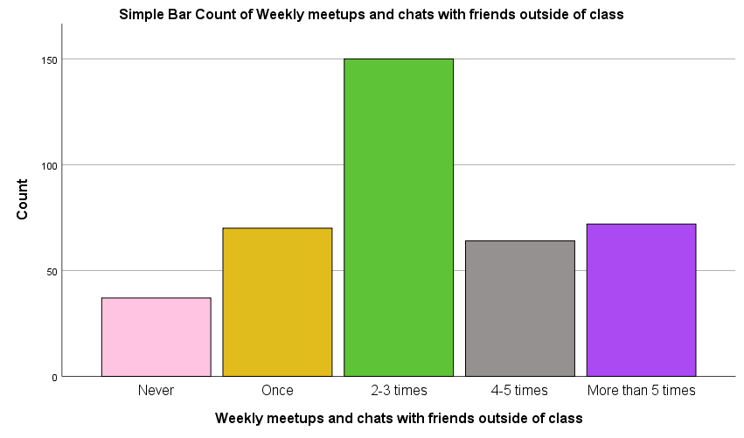

**Figure 3.17:** Weekly meetups and chats with friends outside of class

### Association Table of the Characteristics

*Table 3.18: Association Table*

| **Characteristic** | **Never**  N = 31 | **Rarely**  N = 105 | **Sometimes**  N = 195 | **Often**  N = 49 | **Always**  N = 13 | **Overall**  N = 393 | **p-value***1* |
| --- | --- | --- | --- | --- | --- | --- | --- |
| **Sex, n (%)** |  |  |  |  |  |  | 0.244 |
| Male | 22 (70.97) | 63 (60.00) | 100 (51.28) | 28 (57.14) | 8 (61.54) | 221 (56.23) |  |
| Female | 9 (29.03) | 42 (40.00) | 95 (48.72) | 21 (42.86) | 5 (38.46) | 172 (43.77) |  |
| **Age, n (%)** |  |  |  |  |  |  | 0.413 |
| Age under 22 | 9 (29.03) | 29 (27.62) | 63 (32.31) | 21 (42.86) | 5 (38.46) | 127 (32.32) |  |
| Greater than or equal to 22 | 22 (70.97) | 76 (72.38) | 132 (67.69) | 28 (57.14) | 8 (61.54) | 266 (67.68) |  |
| **Residence, n (%)** |  |  |  |  |  |  |  |
| Hall | 11 (35.48) | 55 (52.38) | 89 (45.64) | 18 (36.73) | 6 (46.15) | 179 (45.55) |  |
| Mess | 16 (51.61) | 42 (40.00) | 95 (48.72) | 23 (46.94) | 4 (30.77) | 180 (45.80) |  |
| With family | 4 (12.90) | 8 (7.62) | 11 (5.64) | 8 (16.33) | 3 (23.08) | 34 (8.65) |  |
| **Monthly family income, n (%)** |  |  |  |  |  |  |  |
| Less than BDT 18,000 per month | 11 (35.48) | 40 (38.10) | 73 (37.44) | 20 (40.82) | 3 (23.08) | 147 (37.40) |  |
| BDT 18,000 to BDT 45,000 per month | 17 (54.84) | 48 (45.71) | 101 (51.79) | 24 (48.98) | 6 (46.15) | 196 (49.87) |  |
| BDT 45,000 to BDT 135,000 per month | 3 (9.68) | 16 (15.24) | 17 (8.72) | 4 (8.16) | 4 (30.77) | 44 (11.20) |  |
| More than BDT 135,000 per month | 0 (0.00) | 1 (0.95) | 4 (2.05) | 1 (2.04) | 0 (0.00) | 6 (1.53) |  |
| **Academic faculty, n (%)** |  |  |  |  |  |  | 0.261 |
| Science and Engineering | 21 (67.74) | 62 (59.05) | 100 (51.28) | 26 (53.06) | 5 (38.46) | 214 (54.45) |  |
| Non-Science and Engineering | 10 (32.26) | 43 (40.95) | 95 (48.72) | 23 (46.94) | 8 (61.54) | 179 (45.55) |  |
| **Current academic status, n (%)** |  |  |  |  |  |  | 0.390 |
| Undergraduate | 29 (93.55) | 88 (83.81) | 174 (89.23) | 44 (89.80) | 13 (100.00) | 348 (88.55) |  |
| Graduated | 2 (6.45) | 17 (16.19) | 21 (10.77) | 5 (10.20) | 0 (0.00) | 45 (11.45) |  |
| **Participation in extracurricular activities, n (%)** | 18 (58.06) | 61 (58.10) | 123 (63.08) | 24 (48.98) | 7 (53.85) | 233 (59.29) | 0.469 |
| **Internet connection availability, n (%)** | 28 (90.32) | 104 (99.05) | 190 (97.44) | 48 (97.96) | 13 (100.00) | 383 (97.46) | 0.166 |
| **Frequent internet use, n (%)** | 26 (83.87) | 99 (94.29) | 165 (84.62) | 47 (95.92) | 12 (92.31) | 349 (88.80) | 0.031 |
| **Average daily hours spent online for non-academic purposes, n (%)** |  |  |  |  |  |  |  |
| Less than 2 hours | 9 (29.03) | 6 (5.71) | 15 (7.69) | 5 (10.20) | 1 (7.69) | 36 (9.16) |  |
| 2-4 hours | 9 (29.03) | 43 (40.95) | 80 (41.03) | 13 (26.53) | 4 (30.77) | 149 (37.91) |  |
| 4-6 hours | 5 (16.13) | 37 (35.24) | 70 (35.90) | 15 (30.61) | 3 (23.08) | 130 (33.08) |  |
| Above 6 hours | 8 (25.81) | 19 (18.10) | 30 (15.38) | 16 (32.65) | 5 (38.46) | 78 (19.85) |  |
| **Online part-time job, n (%)** | 5 (16.13) | 11 (10.48) | 13 (6.67) | 4 (8.16) | 1 (7.69) | 34 (8.65) | 0.395 |
| **Feel anxious without internet access for a few hours, n (%)** |  |  |  |  |  |  |  |
| Never | 15 (48.39) | 17 (16.19) | 16 (8.21) | 4 (8.16) | 1 (7.69) | 53 (13.49) |  |
| Sometimes | 14 (45.16) | 79 (75.24) | 150 (76.92) | 34 (69.39) | 3 (23.08) | 280 (71.25) |  |
| Always | 2 (6.45) | 9 (8.57) | 29 (14.87) | 11 (22.45) | 9 (69.23) | 60 (15.27) |  |
| **Importance of internet connectivity for maintaining relationships with friends and family, n (%)** |  |  |  |  |  |  |  |
| Very importan | 15 (48.39) | 37 (35.24) | 57 (29.23) | 17 (34.69) | 5 (38.46) | 131 (33.33) |  |
| Importan | 11 (35.48) | 39 (37.14) | 100 (51.28) | 22 (44.90) | 4 (30.77) | 176 (44.78) |  |
| Slightly importan | 5 (16.13) | 27 (25.71) | 35 (17.95) | 7 (14.29) | 3 (23.08) | 77 (19.59) |  |
| Not importan | 0 (0.00) | 2 (1.90) | 3 (1.54) | 3 (6.12) | 1 (7.69) | 9 (2.29) |  |
| **Often feel lonely, n (%)** | 1 (3.23) | 46 (43.81) | 134 (68.72) | 46 (93.88) | 13 (100.00) | 240 (61.07) | <0.001 |
| **Reason for your loneliness, n (%)** |  |  |  |  |  |  |  |
| Introvert | 2 (6.45) | 16 (15.24) | 28 (14.36) | 15 (30.61) | 2 (15.38) | 63 (16.03) |  |
| Few friends | 0 (0.00) | 14 (13.33) | 20 (10.26) | 5 (10.20) | 1 (7.69) | 40 (10.18) |  |
| Family problem | 1 (3.23) | 7 (6.67) | 26 (13.33) | 8 (16.33) | 3 (23.08) | 45 (11.45) |  |
| Personal Relationships | 2 (6.45) | 10 (9.52) | 11 (5.64) | 4 (8.16) | 3 (23.08) | 30 (7.63) |  |
| Distance from Home | 8 (25.81) | 38 (36.19) | 67 (34.36) | 9 (18.37) | 2 (15.38) | 124 (31.55) |  |
| Others | 18 (58.06) | 20 (19.05) | 43 (22.05) | 8 (16.33) | 2 (15.38) | 91 (23.16) |  |
| **Using internet to escape loneliness, n (%)** |  |  |  |  |  |  |  |
| Yes | 11 (35.48) | 56 (53.33) | 121 (62.05) | 33 (67.35) | 11 (84.62) | 232 (59.03) |  |
| No | 15 (48.39) | 19 (18.10) | 33 (16.92) | 5 (10.20) | 2 (15.38) | 74 (18.83) |  |
| Rarely | 5 (16.13) | 30 (28.57) | 41 (21.03) | 11 (22.45) | 0 (0.00) | 87 (22.14) |  |
| **Experienced any mental health issues, n (%)** | 5 (16.13) | 24 (22.86) | 61 (31.28) | 19 (38.78) | 9 (69.23) | 118 (30.03) | 0.003 |
| **Internet usage affecting academic performance, n (%)** |  |  |  |  |  |  |  |
| Yes | 20 (64.52) | 66 (62.86) | 127 (65.13) | 30 (61.22) | 9 (69.23) | 252 (64.12) |  |
| No | 9 (29.03) | 17 (16.19) | 34 (17.44) | 8 (16.33) | 3 (23.08) | 71 (18.07) |  |
| Not sure | 2 (6.45) | 22 (20.95) | 34 (17.44) | 11 (22.45) | 1 (7.69) | 70 (17.81) |  |
| **Internet usage impact on sleep quality, n (%)** |  |  |  |  |  |  |  |
| Significantly | 9 (29.03) | 36 (34.29) | 58 (29.74) | 19 (38.78) | 7 (53.85) | 129 (32.82) |  |
| Moderately | 5 (16.13) | 30 (28.57) | 66 (33.85) | 14 (28.57) | 3 (23.08) | 118 (30.03) |  |
| Slightly | 6 (19.35) | 25 (23.81) | 46 (23.59) | 12 (24.49) | 2 (15.38) | 91 (23.16) |  |
| Not at all | 11 (35.48) | 14 (13.33) | 25 (12.82) | 4 (8.16) | 1 (7.69) | 55 (13.99) |  |
| **Hours slept per day, n (%)** |  |  |  |  |  |  |  |
| Less than 4 hours | 1 (3.23) | 1 (0.95) | 6 (3.08) | 0 (0.00) | 2 (15.38) | 10 (2.54) |  |
| 4-6 hours | 7 (22.58) | 26 (24.76) | 66 (33.85) | 15 (30.61) | 7 (53.85) | 121 (30.79) |  |
| 6-8 hours | 20 (64.52) | 61 (58.10) | 107 (54.87) | 28 (57.14) | 3 (23.08) | 219 (55.73) |  |
| More than 8 hours | 3 (9.68) | 17 (16.19) | 16 (8.21) | 6 (12.24) | 1 (7.69) | 43 (10.94) |  |
| **Weekly meetups and chats with friends outside of class, n (%)** |  |  |  |  |  |  |  |
| Never | 6 (19.35) | 9 (8.57) | 16 (8.21) | 4 (8.16) | 2 (15.38) | 37 (9.41) |  |
| Once | 0 (0.00) | 19 (18.10) | 36 (18.46) | 10 (20.41) | 5 (38.46) | 70 (17.81) |  |
| 2-3 times | 8 (25.81) | 40 (38.10) | 82 (42.05) | 19 (38.78) | 1 (7.69) | 150 (38.17) |  |
| 4-5 times | 4 (12.90) | 17 (16.19) | 31 (15.90) | 9 (18.37) | 3 (23.08) | 64 (16.28) |  |
| More than 5 times | 13 (41.94) | 20 (19.05) | 30 (15.38) | 7 (14.29) | 2 (15.38) | 72 (18.32) |  |
| *1*Pearson's Chi-squared test; Fisher's exact test | | | | | | | |

The study investigates factors associated with students' frequency of experiencing loneliness, analyzing demographic characteristics, academic and social behaviors, internet usage patterns, and mental health. Of the sample, 7.89% reported never experiencing loneliness, while the majority experienced loneliness with varying frequency: 26.72% rarely, 49.62% sometimes, 12.47% often, and 3.31% always. This breakdown suggests that occasional and moderate levels of loneliness are common among students, with a smaller subset experiencing chronic loneliness.

**Demographic Characteristics**

Gender and age show no significant associations with loneliness frequency (p-values of 0.244 and 0.413, respectively). Male students constitute the majority across all loneliness categories, with a slightly higher representation in the “never” (70.97%) and “rarely” (60.00%) groups. Age distribution is relatively consistent, with a majority of students aged 22 and above in each category, though younger students (<22 years) show a slightly higher prevalence in the “often” (42.86%) and “always” (38.46%) categories. These findings indicate that, within this sample, loneliness is experienced across gender and age groups without significant demographic bias.

**Residence and Family Income**

Students' residence type is not significantly associated with loneliness frequency, although patterns suggest that those living in messes (45.80%) or with family (8.65%) experience loneliness more frequently. Students living in university halls show a slightly lower proportion in the "often" (36.73%) and "always" (46.15%) categories compared to those in other accommodations.

In terms of monthly family income, students from lower-income backgrounds (earning below BDT 45,000) are more prevalent in the “sometimes” (51.79%) and “often” (48.98%) loneliness categories, though income level shows no significant association with loneliness (p > 0.05). A small percentage (1.53%) of students from higher-income families (BDT 135,000 and above) are present across all levels of loneliness, indicating that economic background alone does not necessarily predict loneliness frequency.

**Academic Characteristics**

The frequency of experiencing loneliness is consistent across academic faculties and levels (p = 0.261 and p = 0.390, respectively). Students in Science and Engineering slightly dominate across all categories except “always” (38.46%), where Non-Science and Engineering students are more represented. Most students in each loneliness category are undergraduates (88.55%), aligning with the general makeup of the sample.

**Internet Usage Patterns**

A significant association is observed between **Frequent Internet Use** and loneliness frequency (p = 0.031). Students who report frequent internet use are notably prevalent in the "rarely" (94.29%), "often" (95.92%), and "always" (92.31%) loneliness categories, suggesting a potential connection between high internet engagement and increased loneliness levels. This is further supported by **Average Daily Hours Spent Online for Non-Academic Purposes**, where students spending more than 6 hours daily are more frequent in the "often" (32.65%) and "always" (38.46%) categories, though this trend does not reach statistical significance (p > 0.05).

**Psychological and Social Factors**

Significant associations emerge between **Feelings of Anxiety Without Internet Access** and loneliness frequency (p < 0.001). The proportion of students who feel anxious “always” without internet access increases with the frequency of loneliness: from 8.57% in the “rarely” category to 69.23% in the “always” category, indicating that higher levels of anxiety without internet access may coincide with more frequent loneliness experiences.

In terms of **Internet Connectivity for Maintaining Relationships**, loneliness does not appear significantly related to students’ reliance on the internet for social connections (p > 0.05), although those who rate it as “important” or “very important” are moderately represented in all loneliness categories.

The analysis also reveals a highly significant association between **Experienced Mental Health Issues** and loneliness frequency (p = 0.003). Students reporting mental health issues are most prevalent in the "always" category (69.23%) and less so among those who “never” feel lonely (16.13%), suggesting that loneliness may be an indicator of or contributor to mental health challenges in this group.

**Academic Performance and Sleep Patterns**

Loneliness frequency appears linked to **Internet Usage Impact on Academic Performance**, with 64.12% of students reporting a negative impact. However, academic performance alone shows no statistically significant relationship with loneliness frequency (p > 0.05). Similarly, **Internet Usage Impact on Sleep Quality** shows a higher proportion of students with significant sleep disruption in the "always" category (53.85%), though this association does not reach statistical significance.

Regarding **Hours Slept Per Day**, students who report sleeping between 6-8 hours make up the majority across loneliness categories. However, students with fewer than 4 hours of sleep show a notable presence in the "always" category (15.38%), suggesting that limited sleep may exacerbate loneliness in a subset of students.

**Social Engagement**

The frequency of **Weekly Meetups and Chats with Friends Outside of Class** does not show a significant association with loneliness frequency. However, students meeting friends more than five times a week are more prevalent in the “never” (41.94%) and “rarely” (19.05%) categories, indicating that frequent in-person interactions may provide a buffer against loneliness.

### Simple Logistic Regression Model

*Table 3.19 Simple Logistic Regression Model*

|  | **Unadjusted** | | **Adjusted** | |
| --- | --- | --- | --- | --- |
| **Characteristic** | **OR (95% CI)***1* | **p-value** | **OR (95% CI)***1* | **p-value** |
| **Sex** |  |  |  |  |
| Female | — |  | — |  |
| Male | 0.50 (0.21, 1.08) | 0.090 | 0.12 (0.00, 2.05) | 0.161 |
| **Age** |  |  |  |  |
| age under 22 | — |  | — |  |
| greater than or equal to 22 | 0.85 (0.36, 1.84) | 0.684 | 2.77 (0.41, 20.2) | 0.290 |
| **Residence** |  |  |  |  |
| Hall | — |  | — |  |
| Mess | 0.67 (0.29, 1.48) | 0.327 | 0.43 (0.05, 2.78) | 0.396 |
| With family | 0.49 (0.16, 1.86) | 0.249 | 0.07 (0.00, 3.68) | 0.231 |
| **Monthly family income** |  |  |  |  |
| More than BDT 135,000 per month | — |  | — |  |
| Less than BDT 18,000 per month | 0.00 () | 0.989 | 0.00 () | 0.998 |
| BDT 18,000 to BDT 45,000 per month | 0.00 () | 0.988 | 0.00 () | 0.998 |
| BDT 45,000 to BDT 135,000 per month | 0.00 (0.00, 4,803,537,600,745,802) | 0.989 | 0.00 () | 0.998 |
| **Academic faculty** |  |  |  |  |
| Science and Engineering | — |  | — |  |
| Non-Science and Engineering | 1.84 (0.86, 4.18) | 0.126 | 0.68 (0.07, 5.30) | 0.715 |
| **Current academic status** |  |  |  |  |
| Graduated | — |  | — |  |
| Undergraduate | 0.51 (0.08, 1.78) | 0.371 | 0.09 (0.00, 1.89) | 0.170 |
| **Participation in extracurricular activities** |  |  |  |  |
| No | — |  | — |  |
| Yes | 1.06 (0.49, 2.21) | 0.885 | 7.58 (0.83, 107) | 0.093 |
| **Internet connection availability** |  |  |  |  |
| No | — |  | — |  |
| Yes | 5.43 (1.12, 20.7) | 0.018 | 4.52 (0.00, 246,122) | 0.845 |
| **Frequent internet use** |  |  |  |  |
| No | — |  | — |  |
| Yes | 1.59 (0.52, 4.08) | 0.368 | 0.17 (0.01, 2.65) | 0.251 |
| **Average daily hours spent online for non-academic purposes** |  |  |  |  |
| Less than 2 hours | — |  | — |  |
| 2-4 hours | 5.19 (1.87, 14.5) | 0.001 | 93.6 (4.76, 4,959) | 0.008 |
| 4-6 hours | 8.33 (2.67, 29.0) | <0.001 | 245 (11.8, 16,789) | 0.002 |
| Above 6 hours | 2.92 (1.02, 8.54) | 0.046 | 5.46 (0.28, 156) | 0.281 |
| **Online part-time job** |  |  |  |  |
| No | — |  | — |  |
| Yes | 0.45 (0.17, 1.42) | 0.132 | 1.22 (0.15, 10.7) | 0.850 |
| **Feel anxious without internet access for a few hours** |  |  |  |  |
| Never | — |  | — |  |
| Sometimes | 7.50 (3.35, 16.9) | <0.001 | 70.8 (5.46, 2,411) | 0.005 |
| Always | 11.4 (3.01, 75.3) | 0.002 | 379 (8.67, 75,769) | 0.008 |
| **Importance of internet connectivity for maintaining relationships with friends and family** |  |  |  |  |
| Not importan | — |  | — |  |
| Very importan | 0.00 () | 0.986 | 0.00 () | 0.998 |
| Importan | 0.00 () | 0.986 | 0.00 () | 0.998 |
| Slightly importan | 0.00 (0.00, 506,168,982,445) | 0.986 | 0.00 () | 0.998 |
| **Often feel lonely** |  |  |  |  |
| No | — |  | — |  |
| Yes | 58.3 (12.3, 1,044) | <0.001 | 6,107 (80.1, 11,452,774) | 0.003 |
| **Using internet to escape loneliness** |  |  |  |  |
| No | — |  | — |  |
| Yes | 5.11 (2.24, 12.0) | <0.001 | 0.48 (0.05, 3.82) | 0.506 |
| Rarely | 4.17 (1.52, 13.4) | 0.009 | 6.88 (0.51, 155) | 0.171 |
| **Experienced any mental health issues** |  |  |  |  |
| No | — |  | — |  |
| Yes | 2.36 (0.96, 7.12) | 0.087 | 1.97 (0.19, 25.5) | 0.574 |
| **Internet usage affecting academic performance** |  |  |  |  |
| No | — |  | — |  |
| Yes | 1.68 (0.70, 3.79) | 0.221 | 0.57 (0.07, 3.64) | 0.567 |
| Not sure | 4.94 (1.21, 33.2) | 0.046 | 7.71 (0.33, 410) | 0.242 |
| **Internet usage impact on sleep quality** |  |  |  |  |
| Not at all | — |  | — |  |
| Significantly | 3.33 (1.30, 8.80) | 0.013 | 0.11 (0.00, 2.04) | 0.160 |
| Moderately | 5.65 (1.94, 18.8) | 0.002 | 1.40 (0.06, 31.1) | 0.831 |
| Slightly | 3.54 (1.26, 10.9) | 0.019 | 0.83 (0.05, 13.2) | 0.889 |
| **Hours slept per day** |  |  |  |  |
| More than 8 hours | — |  | — |  |
| Less than 4 hours | 0.68 (0.08, 14.5) | 0.746 | 0.12 (0.00, 33.8) | 0.461 |
| 4-6 hours | 1.22 (0.25, 4.63) | 0.779 | 0.01 (0.00, 0.23) | 0.018 |
| 6-8 hours | 0.75 (0.17, 2.31) | 0.649 | 0.03 (0.00, 0.64) | 0.063 |
| *1*OR = Odds Ratio, CI = Confidence Interval | | | | |

The logistic regression analysis examines the associations between various demographic, academic, social, and internet-related characteristics and the frequency of experiencing loneliness among students. Both unadjusted and adjusted odds ratios (ORs) are provided, highlighting changes in associations after controlling for potential confounding factors.

Sex does not show a significant association with loneliness frequency in either model. While male students appear to have a slightly lower likelihood of frequent loneliness compared to females in the unadjusted model (OR = 0.50, p = 0.090), this association diminishes further after adjustment (OR = 0.12, p = 0.161). Age also shows no significant relationship with loneliness; students aged 22 or older show lower odds of loneliness in the unadjusted model (OR = 0.85, p = 0.684), but this shifts slightly in the adjusted model (OR = 2.77, p = 0.290), indicating minimal impact from age after adjustment.

Internet connection availability appears to be associated with loneliness in the unadjusted model, with students who have internet access showing significantly higher odds of loneliness (OR = 5.43, p = 0.018). However, this association becomes non-significant after controlling for other variables (OR = 4.52, p = 0.845). Frequent internet use does not show a statistically significant association with loneliness in either model, though it is associated with higher odds in the unadjusted analysis (OR = 1.59, p = 0.368) and lower odds after adjustment (OR = 0.17, p = 0.251).

The amount of time spent online for non-academic purposes reveals a strong relationship with loneliness. Students who spend 2-4 hours online daily show significantly higher odds of loneliness in both unadjusted (OR = 5.19, p = 0.001) and adjusted models (OR = 93.6, p = 0.008). Similarly, those who spend 4-6 hours online have even greater odds in both models (unadjusted OR = 8.33, p < 0.001; adjusted OR = 245, p = 0.002), emphasizing the potential negative impact of extensive internet use on loneliness.

Feelings of anxiety without internet access emerge as one of the strongest predictors of loneliness. Students who feel “sometimes” anxious when without internet access show significantly higher odds of loneliness in both unadjusted (OR = 7.50, p < 0.001) and adjusted models (OR = 70.8, p = 0.005). Those who “always” feel anxious in the absence of internet access experience even greater odds (unadjusted OR = 11.4, p = 0.002; adjusted OR = 379, p = 0.008), suggesting a strong link between internet dependency and frequent loneliness.

Students who reported “often” feeling lonely also have substantially higher odds of frequent loneliness, which is evident in both models. The unadjusted OR is 58.3 (p < 0.001), which increases dramatically in the adjusted model (OR = 6,107, p = 0.003), establishing this variable as a critical predictor of loneliness frequency.

The use of the internet as a means to cope with loneliness shows an interesting pattern. In the unadjusted model, students who use the internet to escape loneliness have significantly higher odds of frequent loneliness (OR = 5.11, p < 0.001), although this association weakens and becomes non-significant after adjustment (OR = 0.48, p = 0.506). This finding suggests that, while internet-based coping mechanisms may be common, other factors likely contribute to the experience of loneliness beyond internet use alone.

Mental health issues are associated with a higher likelihood of loneliness in the unadjusted model (OR = 2.36, p = 0.087), although this relationship is not statistically significant. After adjustment, this association slightly diminishes (OR = 1.97, p = 0.574), indicating that other factors might account for the observed link between mental health and loneliness.

Internet usage’s impact on sleep quality demonstrates notable effects in the unadjusted model. Students reporting significant sleep disruptions due to internet use show higher odds of loneliness (OR = 3.33, p = 0.013 for significant impact; OR = 5.65, p = 0.002 for moderate impact). However, these associations become non-significant in the adjusted model, suggesting that other factors may underlie the relationship between internet-related sleep disruption and loneliness.

Hours slept per day shows an inverse relationship with loneliness in the adjusted model. Students who sleep 4-6 hours per night exhibit significantly lower odds of loneliness (OR = 0.01, p = 0.018), suggesting that moderate sleep duration may help mitigate loneliness.

In summary, the strongest predictors of loneliness frequency include average daily hours spent online for non-academic purposes, feelings of anxiety without internet access, and frequent feelings of loneliness. Students who frequently experience anxiety without internet access, spend prolonged hours online, or use the internet as a coping mechanism for loneliness show higher odds of experiencing loneliness more frequently. This analysis highlights the potential psychological and social implications of internet use on student well-being, particularly in terms of sleep patterns, mental health, and the need for balanced digital habits.

### Contingency Analysis

In this section, contingency analysis will be done to test the independence by chi-square test between variables. $χ^{2}$ 
 test of independence uses expected and observed frequency from the contingency table. The formula is given below-

$$χ^{2}=\sum{ }\sum{ }\frac{o_{pq}^{2}}{E_{pq}}-N∼χ_{(m-1)(n-1)}^{2}$$

Here, $O_{pq}=$ 
 Obseved frequency of $p^{\text{th} }$ row and $q^{\text{th }}$ column $m=$ 
 Total number of rows $n=$ 
 Total number of columns $N=$ 
 Total number of frequencies $E_{pq}=$ 
 Expected frequency of $p^{\text{th }}$ row and $q^{\text{th }}$ column

Where

$$E_{pq}=\frac{R_{p}*C_{q}}{N}$$

Here,

$$R_{p}=\text{ Sum of }p^{\text{th }}\text{ row}$$

$$C_{q}=\text{ Sum of }q^{\text{th }}\text{ column}$$

We'll proceed by following the given algorithm below about how to conduct contingency analysis.

Step 1: Set Hypothesis  
Step 2: Set Significance Level ( $P=0.05$; Two-tailed)

Step 3: Check Assumptions  
 (i)Independence (ii) Expected Frequencies ( $5<20\%$)

Step 4: Compute Chi-Square test for independence in SPSS

Step 5: Make Decision.

Reject H0(P<0.05)  
Step 6: Calculate Effect Size (0.1=small, $0.3=$ medium, $0.5=$ large $)$

### Association between Frequency of Experiencing Loneliness vs Frequent Internet Use

We would like to follow the steps to check the association between these two variables. $H_{0}$ 
 : There is no association between Frequency of Experiencing Loneliness vs Frequent Internet Use. $H_{1}$ 
 : There is an association.

**Bivariate table:**

|  |  |  |  |  |  |
| --- | --- | --- | --- | --- | --- |
| **Frequency of Experiencing Loneliness * Frequent Internet Use: Crosstabulation** | | | | | |
|  | | | Frequent Internet Use | | Total |
| Yes | No |
| Frequency of Experiencing Loneliness | Never | Count | 26 | 5 | 31 |
| Expected Count | 27.5 | 3.5 | 31.0 |
| Rarely | Count | 99 | 6 | 105 |
| Expected Count | 93.2 | 11.8 | 105.0 |
| Sometimes | Count | 165 | 30 | 195 |
| Expected Count | 173.2 | 21.8 | 195.0 |
| Often | Count | 47 | 2 | 49 |
| Expected Count | 43.5 | 5.5 | 49.0 |
| Always | Count | 12 | 1 | 13 |
| Expected Count | 11.5 | 1.5 | 13.0 |
| Total | | Count | 349 | 44 | 393 |
| Expected Count | 349.0 | 44.0 | 393.0 |

**Test Results:**

|  |  |  |  |
| --- | --- | --- | --- |
| **Chi-Square Tests** | | | |
|  | Value | df | Asymptotic Significance (2-sided) |
| Pearson Chi-Square | 10.028a | 4 | .040 |
| Likelihood Ratio | 10.978 | 4 | .027 |
| Linear-by-Linear Association | .094 | 1 | .759 |
| N of Valid Cases | 393 |  |  |
| a. 2 cells (20.0%) have expected count less than 5. The minimum expected count is 1.46. | | | |

**Comment:** From the results, we observe that the asymptotic significance (2-sided) values for both the Pearson Chi-Square and the Likelihood Ratio with 4 degrees of freedom are 0.040 and 0.027, respectively. Both test results are significant at the 5% level of significance. Thus, we reject the null hypothesis and conclude that there is an association between the frequency of experiencing loneliness and frequent internet use among the respondents.

### Association between Frequency of Experiencing Loneliness vs Average Daily Hours Spent Online for Non-Academic Purposes

We would like to follow the steps to check the association between these two variables. $H_{0}$ 
 : There is no association between Frequency of Experiencing Loneliness vs Average Daily Hours Spent Online for Non-Academic Purposes. $H_{1}$ 
 : There is an association.

**Bivariate table:**

|  |  |  |  |  |  |  |  |
| --- | --- | --- | --- | --- | --- | --- | --- |
| **Frequency of Experiencing Loneliness * Average Daily Hours Spent Online for Non-Academic Purposes: Crosstabulation** | | | | | | | |
|  | | | Average Daily Hours Spent Online for Non-Academic Purposes | | | | Total |
| Less than 2 hours | 2-4 hours | 4-6 hours | Above 6 hours |
| Frequency of experiencing loneliness | Never | Count | 9 | 9 | 5 | 8 | 31 |
| Expected Count | 2.8 | 11.8 | 10.3 | 6.2 | 31.0 |
| Rarely | Count | 6 | 43 | 37 | 19 | 105 |
| Expected Count | 9.6 | 39.8 | 34.7 | 20.8 | 105.0 |
| Sometimes | Count | 15 | 80 | 70 | 30 | 195 |
| Expected Count | 17.9 | 73.9 | 64.5 | 38.7 | 195.0 |
| Often | Count | 5 | 13 | 15 | 16 | 49 |
| Expected Count | 4.5 | 18.6 | 16.2 | 9.7 | 49.0 |
| Always | Count | 1 | 4 | 3 | 5 | 13 |
| Expected Count | 1.2 | 4.9 | 4.3 | 2.6 | 13.0 |
| Total | | Count | 36 | 149 | 130 | 78 | 393 |
| Expected Count | 36.0 | 149.0 | 130.0 | 78.0 | 393.0 |

**Test Results:**

|  |  |  |  |
| --- | --- | --- | --- |
| **Chi-Square Tests** | | | |
|  | Value | df | Asymptotic Significance (2-sided) |
| Pearson Chi-Square | 31.305a | 12 | .002 |
| Likelihood Ratio | 26.501 | 12 | .009 |
| Linear-by-Linear Association | 3.959 | 1 | .047 |
| N of Valid Cases | 393 |  |  |
| a. 6 cells (30.0%) have expected count less than 5. The minimum expected count is 1.19. | | | |

**Comment:** From the results, we see that the asymptotic significance (2-sided) values of both the Pearson Chi-Square and the Likelihood Ratio with 12 degrees of freedom are 0.002 and 0.009, respectively. Both test results are significant at the 5% level of significance, so we reject the null hypothesis and conclude that there is an association between the frequency of experiencing loneliness and the average daily hours spent online for non-academic purposes among the respondents.

### Association between Frequency of Experiencing Loneliness vs Feelings of Anxiety Without Internet Access

We would like to follow the steps to check the association between these two variables. $H_{0}$ 
 : There is no association between Frequency of Experiencing Loneliness vs Feelings of Anxiety Without Internet Access. $H_{1}$ 
 : There is an association.

**Bivariate table:**

|  |  |  |  |  |  |  |
| --- | --- | --- | --- | --- | --- | --- |
| **Frequency of Experiencing Loneliness * Feelings of Anxiety Without Internet Access: Crosstabulation** | | | | | | |
|  | | | Feelings of Anxiety Without Internet Access | | | Total |
| Never | Sometimes | Always |
| Frequency of Experiencing Loneliness | Never | Count | 15 | 14 | 2 | 31 |
| Expected Count | 4.2 | 22.1 | 4.7 | 31.0 |
| Rarely | Count | 17 | 79 | 9 | 105 |
| Expected Count | 14.2 | 74.8 | 16.0 | 105.0 |
| Sometimes | Count | 16 | 150 | 29 | 195 |
| Expected Count | 26.3 | 138.9 | 29.8 | 195.0 |
| Often | Count | 4 | 34 | 11 | 49 |
| Expected Count | 6.6 | 34.9 | 7.5 | 49.0 |
| Always | Count | 1 | 3 | 9 | 13 |
| Expected Count | 1.8 | 9.3 | 2.0 | 13.0 |
| Total | | Count | 53 | 280 | 60 | 393 |
| Expected Count | 53.0 | 280.0 | 60.0 | 393.0 |

**Test Results:**

|  |  |  |  |
| --- | --- | --- | --- |
| **Chi-Square Tests** | | | |
|  | Value | df | Asymptotic Significance (2-sided) |
| Pearson Chi-Square | 73.423a | 8 | .000 |
| Likelihood Ratio | 54.119 | 8 | .000 |
| Linear-by-Linear Association | 38.713 | 1 | .000 |
| N of Valid Cases | 393 |  |  |
| a. 4 cells (26.7%) have expected count less than 5. The minimum expected count is 1.75. | | | |

**Comment:** Examining the chi-square results, we find that both the Pearson Chi-Square and the Likelihood Ratio, each with 8 degrees of freedom, have asymptotic significance (2-sided) values of 0.000. This result is significant at the 5% level, leading us to reject the null hypothesis and conclude that there is a strong association between the frequency of experiencing loneliness and feelings of anxiety without internet access among respondents.

### Association between Frequency of Experiencing Loneliness vs Experienced any mental health issues

We would like to follow the steps to check the association between these two variables. $H_{0}$ 
 : There is no association between Frequency of Experiencing Loneliness vs Experienced any mental health issues. $H_{1}$ 
 : There is an association.

**Bivariate table:**

|  |  |  |  |  |  |
| --- | --- | --- | --- | --- | --- |
| **Frequency of Experiencing Loneliness * Experienced any mental health issues: Crosstabulation** | | | | | |
|  | | | Experienced any mental health issues | | Total |
| Yes | No |
| Frequency of Experiencing Loneliness | Never | Count | 5 | 26 | 31 |
| Expected Count | 9.3 | 21.7 | 31.0 |
| Rarely | Count | 24 | 81 | 105 |
| Expected Count | 31.5 | 73.5 | 105.0 |
| Sometimes | Count | 61 | 134 | 195 |
| Expected Count | 58.5 | 136.5 | 195.0 |
| Often | Count | 19 | 30 | 49 |
| Expected Count | 14.7 | 34.3 | 49.0 |
| Always | Count | 9 | 4 | 13 |
| Expected Count | 3.9 | 9.1 | 13.0 |
| Total | | Count | 118 | 275 | 393 |
| Expected Count | 118.0 | 275.0 | 393.0 |

**Test Results:**

|  |  |  |  |
| --- | --- | --- | --- |
| **Chi-Square Tests** | | | |
|  | Value | df | Asymptotic Significance (2-sided) |
| Pearson Chi-Square | 16.860a | 4 | .002 |
| Likelihood Ratio | 16.224 | 4 | .003 |
| Linear-by-Linear Association | 14.433 | 1 | .000 |
| N of Valid Cases | 393 |  |  |
| a. 1 cells (10.0%) have expected count less than 5. The minimum expected count is 3.90. | | | |

**Comment:** The chi-square test results show that the asymptotic significance (2-sided) values for both the Pearson Chi-Square and Likelihood Ratio, each with 4 degrees of freedom, are 0.002 and 0.003, respectively. These values are significant at the 5% level, so we reject the null hypothesis and conclude that there is an association between the frequency of experiencing loneliness and having experienced mental health issues among the respondents.

### Association between Frequency of Experiencing Loneliness vs Weekly meetups and chats with friends outside of class

We would like to follow the steps to check the association between these two variables. $H_{0}$ 
 : There is no association between Frequency of Experiencing Loneliness vs Weekly meetups and chats with friends outside of class. $H_{1}$ 
 : There is an association.

**Bivariate table:**

|  |  |  |  |  |  |  |  |  |
| --- | --- | --- | --- | --- | --- | --- | --- | --- |
| **Frequency of Experiencing Loneliness * Weekly meetups and chats with friends outside of class: Crosstabulation** | | | | | | | | |
|  | | | Weekly meetups and chats with friends outside of class | | | | | Total |
| Never | Once | 2-3 times | 4-5 times | More than 5 times |
| Frequency of Experiencing Loneliness | Never | Count | 6 | 0 | 8 | 4 | 13 | 31 |
| Expected Count | 2.9 | 5.5 | 11.8 | 5.0 | 5.7 | 31.0 |
| Rarely | Count | 9 | 19 | 40 | 17 | 20 | 105 |
| Expected Count | 9.9 | 18.7 | 40.1 | 17.1 | 19.2 | 105.0 |
| Sometimes | Count | 16 | 36 | 82 | 31 | 30 | 195 |
| Expected Count | 18.4 | 34.7 | 74.4 | 31.8 | 35.7 | 195.0 |
| Often | Count | 4 | 10 | 19 | 9 | 7 | 49 |
| Expected Count | 4.6 | 8.7 | 18.7 | 8.0 | 9.0 | 49.0 |
| Always | Count | 2 | 5 | 1 | 3 | 2 | 13 |
| Expected Count | 1.2 | 2.3 | 5.0 | 2.1 | 2.4 | 13.0 |
| Total | | Count | 37 | 70 | 150 | 64 | 72 | 393 |
| Expected Count | 37.0 | 70.0 | 150.0 | 64.0 | 72.0 | 393.0 |

**Test Results:**

|  |  |  |  |
| --- | --- | --- | --- |
| **Chi-Square Tests** | | | |
|  | Value | df | Asymptotic Significance (2-sided) |
| Pearson Chi-Square | 29.875a | 16 | .019 |
| Likelihood Ratio | 32.985 | 16 | .007 |
| Linear-by-Linear Association | 3.637 | 1 | .057 |
| N of Valid Cases | 393 |  |  |
| a. 7 cells (28.0%) have expected count less than 5. The minimum expected count is 1.22. | | | |

**Comment:** The chi-square analysis shows that the asymptotic significance (2-sided) values for the Pearson Chi-Square and Likelihood Ratio, with 16 degrees of freedom, are 0.019 and 0.007, respectively. These results are significant at the 5% level, so we reject the null hypothesis and conclude that there is an association between the frequency of experiencing loneliness and the frequency of weekly meetups and chats with friends outside of class among respondents.

**Overall Representation Of The Previous Findings**

|  |  |  |  |
| --- | --- | --- | --- |
| **Test** | **χ² Value** | **P-Value** | **Interpretation** |
| Frequency of Experiencing Loneliness vs Frequent Internet Use | 10.03 | 0.04 | Significant association. |
| Frequency of Experiencing Loneliness vs Average Daily Hours Spent Online for Non-Academic Purposes | 31.3 | 0.002 | Highly significant association. |
| Frequency of Experiencing Loneliness vs Feelings of Anxiety Without Internet Access | 73.42 | < 0.001 | Strongly significant association. |
| Frequency of Experiencing Loneliness vs Experienced Any Mental Health Issues | 16.86 | 0.002 | Significant association. |
| Frequency of Experiencing Loneliness vs Weekly Meetups and Chats with Friends Outside of Class | 29.88 | 0.019 | Significant association. |

Table of the total representation of the association of the variables.

# Chapter Four

## Result Discussion and Conclusion

### Introduction

This study examined the relationship between internet usage and loneliness among students at Barishal University. Through frequency distribution and regression analyses, various factors were analyzed, including demographic variables, internet usage patterns, and psychological indicators related to loneliness. The analyses revealed significant patterns, particularly highlighting the role of internet usage motives, online engagement levels, and associated psychological stress. These findings provide valuable insights into how digital behavior influences students' mental well-being, particularly concerning loneliness and anxiety.

### Result Discussion

The results of this study illuminate key trends in the relationship between internet usage patterns and loneliness. The frequency distribution analysis revealed that a substantial portion of participants were high-frequency internet users, often engaging in non-academic activities such as social media and entertainment. These individuals reported heightened feelings of loneliness and anxiety, especially when unable to access the internet, indicating a dependency on digital connectivity for emotional support.

Regression analysis identified critical predictors related to loneliness among students. Frequency and motives of internet usage emerged as prominent factors, with students using the internet primarily for social media or recreational activities reporting higher loneliness levels than those who used it for academic purposes. Additionally, students who reported feeling anxious or isolated without internet access showed increased tendencies toward loneliness, suggesting that internet dependency could exacerbate social isolation.

Demographic variables, such as age and academic year, also showed significant associations with loneliness. Older students and those in advanced years of study tended to experience higher levels of loneliness, possibly due to academic pressures and a reduced sense of social integration on campus. Moreover, students residing off-campus displayed higher loneliness levels than those living with family or in university accommodation, pointing to the impact of living arrangements on social well-being.

### Conclusion

In summary, this study highlights a significant association between internet usage patterns and loneliness among Barishal University students. Frequent engagement in non-academic internet activities, combined with internet dependency, appears to contribute to elevated loneliness levels, particularly among older students and those living off-campus. These findings underscore the need for initiatives promoting balanced internet usage and encouraging offline social interactions to mitigate loneliness and enhance students' well-being.

### Limitations

Throughout the research process, several limitations were encountered, including:

1. Time and financial constraints that limited the scope of data collection and analysis.
2. Limited access to advanced data analysis tools and resources, which may have influenced the depth of statistical analysis.
3. Potential response biases, as some students may have withheld personal information regarding their internet usage habits and feelings of loneliness.
4. The potential for inattention in responses, as some students may have answered questions superficially or inaccurately.

### Further Research Scope

The findings of this study open several avenues for future research. Longitudinal studies could provide insights into how internet usage and loneliness evolve over time, particularly as students progress through different academic stages. Additionally, future research could expand the sample to include universities in different regions to determine if similar patterns of internet usage and loneliness are prevalent across broader populations. Investigating the impact of specific internet activities, such as social media usage versus online gaming, on mental well-being could also yield more detailed insights into digital behavior and its psychological effects. Moreover, qualitative studies exploring students' personal experiences with internet usage and loneliness may provide deeper, context-rich understanding and could inform targeted interventions.

# References

• Andreassen, C. S., Torsheim, T., Brunborg, G. S., & Pallesen, S. (2012). Development of a Facebook Addiction Scale. *Psychological Reports, 110*(2), 501–517. https://doi.org/10.2466/02.09.18.PR0.110.2.501-517

• Ceyhan, E., & Ceyhan, A. A. (2008). Loneliness, depression, and computer self-efficacy as predictors of problematic internet use. *Cyberpsychology & Behavior, 11*(6), 699–701. https://doi.org/10.1089/cpb.2007.0253

• Junco, R. (2012). The relationship between frequency of Facebook use, participation in Facebook activities, and student engagement. *Computers & Education, 58*(1), 162–171. https://doi.org/10.1016/j.compedu.2011.08.004

• Kraut, R., Patterson, M., Lundmark, V., Kiesler, S., Mukophadhyay, T., & Scherlis, W. (1998). Internet paradox: A social technology that reduces social involvement and psychological well-being? *American Psychologist, 53*(9), 1017–1031. https://doi.org/10.1037/0003-066X.53.9.1017

• Lemmens, J. S., Valkenburg, P. M., & Peter, J. (2009). Development and validation of a game addiction scale for adolescents. *Media Psychology, 12*(1), 77–95. https://doi.org/10.1080/15213260802669458

• Moore, D., & McElroy, J. C. (2012). The influence of personality on Facebook usage, wall postings, and regret. *Computers in Human Behavior, 28*(1), 267–274. https://doi.org/10.1016/j.chb.2011.09.009

• Primack, B. A., Shensa, A., Sidani, J. E., Whaite, E. O., Lin, L. Y., Rosen, D., Colditz, J. B., Radovic, A., & Miller, E. (2017). Social media use and perceived social isolation among young adults in the U.S. *American Journal of Preventive Medicine, 53*(1), 1–8. https://doi.org/10.1016/j.amepre.2017.01.010

• Valkenburg, P. M., & Peter, J. (2007). Online communication and adolescent well-being: Testing the stimulation versus the displacement hypothesis. *Journal of Computer-Mediated Communication, 12*(4), 1169–1182. https://doi.org/10.1111/j.1083-6101.2007.00368.x

# Appendix A Supportive Materials

|  |  |
| --- | --- |
|  | **Section A: Socio-economic and demographic factors** |
| E/P | **E-mail or phone number** |
| Sex | **Sex** |
| Age | **Age** |
| RE | **Residence** |
| MFI | **Monthly family income** |
|  | **Section B: Institutional factors** |
| AF | **Academic faculty** |
| CAS | **Current academic status** |
| CG | **CGPA/GPA** |
| PEA | **Participation in extracurricular activities** |
|  | **Section C: Internet Usage** |
| ICA | **Internet connection availability** |
| FIU | **Frequent internet use** |
| MMIU | **Main motive for internet usage** |
| ADHSNP | **Average daily hours spent online for non-academic purposes** |
| OPJ | **Online part-time job** |
| FAWI | **Feel anxious without internet access for a few hours** |
| IICMR | **Importance of internet connectivity for maintaining relationships with friends and family** |
|  | **Section D: Loneliness** |
| OFL | **Often feel lonely** |
| FOEL | **Frequency of experiencing loneliness** |
| RFL | **Reason for your loneliness** |
| UIEL | **Using internet to escape loneliness** |
| EAMHI | **Experienced any mental health issues** |
|  | **Section E: Other factors** |
| IUAAP | **Internet usage affecting academic performance** |
| IUISQ | **Internet usage impact on sleep quality** |
| HSPD | **Hours slept per day** |
| WMCWF | **Weekly meetups and chats with friends outside of class** |

# Appendix B Questionnaire

‘‘**Examining the Association Between Internet Usage and Loneliness Among Barishal University Students: A Cross-Sectional Study’’**

**Section A: Socio-economic and demographic factors**

* **E-mail or phone number** (This information will be kept confidential)

**Ans:**

* **Sex**
* Male
* Female
* **Age**

**Ans:**

* **Residence**
  + Hall
  + Mess
  + With family
* **Monthly family income**
  + Less than BDT 18,000 per month
  + BDT 18,000 to BDT 45,000 per month
  + BDT 45,000 to BDT 135,000 per month
  + More than BDT 135,000 per month

**Section B: Institutional factors**

* **Academic faculty**
  + Science and Engineering
  + Bio-Sciences
  + Business Studies
  + Social Sciences
  + Arts and Humanities
  + Law
* **Current academic status**
  + Undergraduate
  + Graduated
* **CGPA/GPA** (If it’s semester, provide the results of your last semester)

**Ans:**

* **Participation in extracurricular activities**
  + Yes
  + No

**Section C: Internet Usage**

* **Internet connection availability**
* Yes
* No
* **Frequent internet use**
* Yes
* No
* **Main motive for internet usage** (Select all that apply)
* Academic purposes
  + Social media and communication
  + Multifaceted learning (Job preparation, Online learning, Coding, etc)
  + Entertainment (Gaming, Streaming videos, etc)
  + News and information
  + Above all
  + Other
* **Average daily hours spent online for non-academic purposes**
  + Less than 2 hours
  + 2-4 hours
  + 4-6 hours
  + Above 6 hours
* **Online part-time job**
* Yes
* No
* **Feel anxious without internet access for a few hours** 
  + - * Never
      * Sometimes
      * Always
* **Importance of internet connectivity for maintaining relationships with friends and family**
* Very important
* Important
* Slightly important
* Not important

**Section D: Loneliness**

* **Often feel lonely**
* Yes
* No
* **Frequency of experiencing loneliness**
  + - Never
    - Rarely
    - Sometimes
    - Often
    - Always
* **Reason for your loneliness**
* Introvert
* Few friends
* Family problem
* Personal Relationships
* Distance from Home
* Others
* **Using internet to escape loneliness**
  + Yes
  + No
  + Rarely
* **Experienced any mental health issues**
  + Yes
  + No

**Section E: Other factors**

* **Internet usage affecting academic performance**
  + Yes
  + No
  + Not sure
* **Internet usage impact on sleep quality**
* Significantly
* Moderately
* Slightly
* Not at all
* **Hours slept per day**
  + - Less than 4 hours
    - 4-6 hours
    - 6-8 hours
    - More than 8 hours
* **Weekly meetups and chats with friends outside of class**
* Never
* Once
* 2-3 times
* 4-5 times
* More than 5 times